**INTRODUCTION**

The Bank Management System project aims to develop a comprehensive software solution that streamlines and automates various banking processes for enhanced operational efficiency, improved customer service, and robust data management. This requirement gathering description outlines the key functionalities, features, and user requirements for the project.

The BCA stream can provide facility to introduction course about programming knowledge by “Saurastra University”. My collage “Shree G.K. & C.K. Bosamia Arts and Commerce Collage, Jetpur” and university rules according can implement the project in BCA SEM-5 is Bank Management System using PHP and MYSQL database.

My Project Works fully Dynamically it has two sides Client Side and Admin Side.

ACKNOWLEDGEMENT

Our Project will successfully development and efforts so many people help for develop a project. “Shree G.K. & C.K. Bosamia Arts and Commerce Collage, Jetpur” give a chance to develop a project under the guidance by “Sakshi Dilersingh Sir”.

I sincerely thank my guide Mr. Sakshi Dilersingh Sir for granting me the permission to develop this project and helping me throughout the project.

I would like to thanks my institute “Shree G.K. & C.K. Bosamia Arts and Commerce Collage, Jetpur” for giving me this opportunity.

**INDEX**

|  |  |  |
| --- | --- | --- |
| **No.** | **Title** | **Page. No.** |
| 1. | Introduction | 1 |
| 2. | Acknowledgement | 2 |
| 3. | Project Profile | 4 |
| 4. | Basic Introduction of my project | 5 |
| 5. | Features | 7 |
| 6. | User Roles And Functionalities | 9 |
| 7. | Project Study (Front End & Back End) | 10 |
| 8. | Requirements | 12 |
| 9. | Reference Website | 14 |
| 10. | Requirement Analysis | 15 |
| 11. | Feasibility Study | 16 |
| 12. | Data Information | 19 |
| 13. | Data Structure | 22 |
| 14. | Data Flow Diagram | 25 |
| 15. | Use Case Diagram | 29 |
| 16. | Flow Chart | 31 |
| 17. | Designing Admin & Client | 33 |
| 18. | Coding | 46 |
| 19. | Error & Solution | 108 |
| 20. | Testing | 110 |
| 21. | limitation | 112 |
| 22. | conclusion | 113 |

**PROJECT PROFILE**

|  |  |
| --- | --- |
| **Project Title** | Bank Management System |
| **Front End** | HTML,CSS,JAVASCRIPT,JQUERY,AJAX |
| **Back End** | MY SQL |
| **Developed For** | Banking Services |
| **Project Description** | Provide Banking Services For customer |
| **Project Duration** | 01-07-2023 to 13-9-2023 |
| **Project Guide** | Sakshi Dilersingh |
| **Developed By** | Bhautik Thumar |
| **Collage Name** | Shree G.K. & C.K. Bosamia Arts & Commerce Collage, Jetpur |
| **Submission Date** | 30-9-2023 |
| **Software Use** | Wampp Server,VScode |

**BASIC INTRODUCTION OF MY PROJECT**

* **What is my project?**
* The Bank Management System is a web application developed in PHP to manage various banking operations efficiently. It provides functionalities for user registration, account creation, transaction handling, and account statements viewing.
* The Bank Management system enables the management of customer accounts, transactions, and other essential banking functions.
* The application allows bank staff to perform their daily tasks, such as account creation, deposit, withdrawal, and fund transfers, while also providing customers with a user-friendly interface to access their accounts and perform transactions online.
* The bank management system contain large numbers of accounts.
* Now a days every people will need the banking facilities our system is full fill the user requirement.
* **Aims of my project :-**
* The aim of the "Bank Management Project" is to develop a user-friendly web application using PHP to effectively manage various banking operations.
* The project aims to design a user-friendly interface that ensures customers can easily navigate the application
* The primary aim is to allows customers to perform different banking operations online. Customers should be able to create account, if customer already have account than they access their accounts, check balances, transfer funds, and view transaction histories , check Aadhar card is link or not if not then provide the link Aadhar facility to user.
* The project aims to simplify the account management process for bank staff. They should be able to easily create, update, or delete customer accounts, and manage customers account and also done transaction related process such as deposit money in account , withdraw money from account.
* The project aims to create a best account approval process. New account requests should be reviewed efficiently, and administrators
* should be able to approve or reject applications easily.
* The project focuses on utilizing PHP as the primary programming language for backend development, ensuring a scalable and maintainable codebase.
* The aim is to integrate a reliable database system, such as MySQL, to efficiently store and manage customer information and transaction records.
* The project aims to implement a responsive design, ensuring that the application is accessible across various devices, including desktops, tablets, and smartphones.
* **Features :-**

**User Authentication**

**Account Management**

**Security**

**Fund Transfer**

**Admin Management**

**Account Approval**

**Transaction History**

**Balance Inquire**

**features**

* **User Authentication:** Customers and administrators can log in to their respective accounts with valid credentials.
* **Account Management:** Customers can create new accounts, view their account details, and see personal information.
* **Balance Inquiry:** Customers can check their account balances at any time.
* **Fund Transfer:** Customers can transfer money between their own accounts or to other registered accounts within the bank.
* **Transaction History:** Customers can view their past transaction history to track their financial activities.
* **Account** **Approval:** Administrators can approve or reject new account requests from customers.
* **Account Management (Admin):** Administrators have the authority to manage customer accounts, including creating, updating, and deleting accounts. Account type and status management (active, closed, etc.).
* **Security**: Secure user authentication and session management. Encryption of sensitive data, such as passwords and financial details. Input validation to prevent code injection and malicious attacks.
* **User Roles And Functionalities :-**

The system will support multiple user roles, including:

* **Customers**: Account holders who can access their accounts, perform transactions, and manage their financial activities.
* **Bank Staff:** Employees responsible for account management, transaction processing, customer support, and administrative tasks.

**User Roles**

**Staff**

**Customers**

Opena An Account All Account Holders List

Transfer Money Deposit Money

Check Balance Withdraw Money

Check Transaction Update An Account Info

Request Debitcard Close An Account

Request Chequebook Approve Pending Account

Show Account info Add New Staff Member

Aadhar Status Add New Customer

Link Aadharcard Change Password

Change Password Show Customers Requests

* **Project Study (Front End & Back End):-**
* **What is PHP ?**
* PHP is an acronym for "PHP: Hypertext Preprocessor"
* PHP is a widely-used, open source scripting language
* PHP scripts are executed on the server
* PHP is free to download and use
* PHP files can contain text, HTML, CSS, JavaScript, and PHP code
* PHP code is executed on the server, and the result is returned to the browser as plain HTML
* PHP files have extension ".php"
* PHP can generate dynamic page content
* PHP can create, open, read, write, delete, and close files on the server
* **What is HTML ?**
* HTML stands for Hyper Text Markup Language
* HTML is the standard markup language for creating Web pages
* HTML describes the structure of a Web page
* HTML consists of a series of elements
* HTML elements tell the browser how to display the content
* HTML elements label pieces of content such as "this is a heading", "this is a paragraph", "this is a link", etc.
* **What is CSS ?**
* CSS stands for Cascading Style Sheets
* CSS describes how HTML elements are to be displayed on screen, paper, or in other media
* CSS saves a lot of work. It can control the layout of multiple web pages all at once
* External stylesheets are stored in CSS files
* **What is JAVA SCRIPT ?**
* JavaScript is a scripting or programming language
* JavaScript allows you to implement complex features on web pages.
* every time a web page does more than just sit there and display static information for you to look at — displaying timely content updates, interactive maps, animated 2D/3D graphics, scrolling video jukeboxes, etc. you can bet that JavaScript is probably involved. It is the third layer of the layer cake of standard web technologies, two of which (HTML and CSS) we have covered in much more detail in other parts of the Learning Area.
* **What is JQUERY ?**
* jQuery is a lightweight, "write less, do more", JavaScript library.
* The purpose of jQuery is to make it much easier to use JavaScript on your website.
* jQuery takes a lot of common tasks that require many lines of JavaScript code to accomplish, and wraps them into methods that you can call with a single line of code.
* jQuery also simplifies a lot of the complicated things from JavaScript, like AJAX calls and DOM manipulation.
* The jQuery library contains the following features:

1. HTML/DOM manipulation
2. CSS manipulation
3. HTML event methods
4. Effects and animations
5. AJAX
6. Utilities

* **What is AJAX ?**
* AJAX is an acronym for Asynchronous JavaScript and XML. It is a group of inter-related technologies like JavaScript, DOM, XML, HTML/XHTML, CSS, XMLHttpRequest etc.
* AJAX allows you to send and receive data asynchronously without reloading the web page. So it is fast.
* AJAX allows you to send only important information to the server not the entire page. So only valuable data from the client side is routed to the server side. It makes your application interactive and faster.
* **What is MYSQL ?**
* MySQL is a database system used on the web
* MySQL is a database system that runs on a server
* MySQL is ideal for both small and large applications
* MySQL is very fast, reliable, and easy to use
* MySQL uses standard SQL
* MySQL compiles on a number of platforms
* MySQL is free to download and use
* MySQL is developed, distributed, and supported by Oracle Corporation
* MySQL is named after co-founder Monty Widenius's daughter: My
* **Requirements :-**

The requirement is a complete description of the behaviour of the system to be developed. These requirements includes: functional, technical requirements and nonfunctional requirements.

* **Functional Requirements :**
* **Customer Module:**
* **User Registration**: Allow customers to create new accounts by providing necessary personal and financial information.
* **Account Management**: Enable customers to view account balances, transaction history, and account details.
* **Funds Transfer:** Allow customers to transfer funds between their accounts, to other customers within the same bank.
* **Account Statements**: Provide customers with digital account statements, transaction summaries.
* **Change password:** the customer can change their password with entering old password.
* **Additional functionality:** The customers request for credit card and cheque and link their Aadhar card with bank account.
* **Bank Staff Module:**
* **Customer Management**: Allow bank staff to create, modify, and deactivate customer accounts. They should also be able to view customer details, account activities, and manage customer support requests.
* **Transaction Processing**: Provide bank staff with functionalities to process transactions, such as deposits, withdrawals, fund transfers.
* **Security Management**: Implement robust security measures such as authentication, encryption, audit trails, and role-based access control to ensure data privacy and prevent unauthorized access.
* **Technical Requirements :**
* **Programming Language:** PHP
* **Database:** Utilize a relational database management system (e.g. MySQL) for data storage and retrieval.
* **Web Server**: Deploy the application on a web server (e.g., Apache) to handle requests and responses.
* **Front-end Development:** Use HTML, CSS, JavaScript, JQUERY and AJAX to create an responsive user interface.
* **Security Measures:** Implement secure coding practices, input validation, protection against SQL injection, and user authentication and authorization mechanisms
* **Non - Functional Requirements :**
* **Security:** The system should adhere to the highest security standards to protect customer data and transactions**.**
* **Scalability:** The solution should be scalable to accommodate a growing customer base and increasing transaction volumes.
* **Performance:** The system should be highly responsive, ensuring quick response times even during peak load periods.
* **Reliability:** The system should be reliable, minimizing downtime and ensuring data integrity.
* **Usability**: The user interface should be intuitive, user-friendly, and accessible across multiple devices and platforms.
* **Integration:** The system should support integration with external systems, such as payment gateways, regulatory reporting systems, and core banking systems**.**
* **Compliance:** The system should comply with relevant banking regulations, data protection laws, and industry standards.
* **Reference website :-**
* <https://bankofindia.co.in/>
* <https://sbi.co.in/>
* <https://www.bankofbaroda.in/>
* <https://www.unionbankofindia.co.in/>
* <https://www.hdfcbank.com/>
* <https://www.unionbankonline.co.in/>
* **Reference Application :-**
* **YONO SBI**
* **Bob World**
* **Requirement Analysis :-**
* Analysis is functional requirement all information gathering. Then important functionality getting and include the requirements of details.
* The purpose of the project is to provide the banking functionalities such as deposit money, withdraw money, fund transfer etc.
* With the increase of popularity of banking services. Banking visit services are convenience for customer so how to make this process easier to customer I have created the banking services project that provide customers to done their financial transaction online.
* The bank management system is provide customer to open an account, check balance, fund transfer, check account details and request for debit card and cheque book and also additional functionalities such as linking the Aadhar linking and Aadhar linking status to customers.
* Now a days the every person need the banking functionalities my project is provide that functionalities to the customers.
* **Feasibility Study :-**
  + An analysis and evaluation of proposed project to determine if it is technology feasible within the estimated cost and will be profitable.
  + There are 5 type of feasibility study including :

1. Technical Feasibility.
2. Scheduling Feasibility .
3. Economic Feasibility.
4. Operational Feasibility.
5. Legal Feasibility.

* **Technical Feasibility :**
* In our project technical feasibility including that our program should work correctly according to user command.
* The Technical feasibility also involves evolutions the hardware software and other technology requirements of the proposed system.
* The developer expertise in HTML, CSS, PHP, JAVASCRIPT, JQUERY, AJAX and database management system.
* **Minimum Hardware Requirements :-**
* Dual Core 64-bit Processor.
* 4 GB RAM.
* Hard disk
* **Minimum Software Requirements :-**
* VS Code.
* Notepad.
* OS-Window-7.
* Wampp Server.
* Chrome or Firefox browser.
* **Economic Feasibility :**
* It is measure of cost effective of the system project and its solution or often called cost benefit analysis
* **Hardware :-**

|  |  |
| --- | --- |
| Keyboard | 570 |
| CPU | 14000 |
| Mouse | 320 |
| Monitor | 10000 |
| **Total** | **24890** |

* **Software :-**

|  |  |
| --- | --- |
| Notepad | Free |
| VS code | Free |
| Wampp | Free |
| Chrome | Free |
| Firefox | Free |

* **Legal Feasibility :**
* The system will adhere to regulations data protection law and industry standards ensuring legal compliance.
* The robust security measure will be implemented to protect customer data and maintain privacy.
* **Operational Feasibility :**
* It is measure of the how well the solution will the solution will work in the organization. It is also the measure of the what people feel about the project.
* **Schedule Feasibility :**

|  |  |  |  |  |
| --- | --- | --- | --- | --- |
| **No** | **Project Task** | **No. of Days** | **Starting Date** | **Ending Date** |
| 1. | Requirement Gathering | 6 | 1-jul-23 | 6-jul-23 |
| 2. | Requirement Analysis | 5 | 7-jul-23 | 11-jul-23 |
| 3. | Feasibility Study | 4 | 12-jul-23 | 15-jul-23 |
| 4. | Data Information | 2 | 16-jul-23 | 17-jul-23 |
| 5. | Data Structure | 7 | 18-jul-23 | 24-jul-23 |
| 6. | Data Flow Diagram:  Admin & Client | 5 | 25-jul-23 | 29-jul-23 |
| 7. | Designing Admin & Client | 5 | 30-jul-23 | 3-aug-23 |
| 8. | Coding | 25 | 4-aug-23 | 28-aug-23 |
| 9. | Error & Solution | 4 | 29-aug-23 | 1-sep-23 |
| 10. | Testing | 3 | 2-sep-23 | 4-sep-23 |
| 11. | Implementation | 4 | 5-sep-23 | 8-sep-23 |
| 12. | Limitations | 2 | 9-sep-23 | 10-sep-23 |
| 13. | Conclusions | 3 | 11-sep-23 | 13-sep-23 |

* **Data Information :-**
* **Table : user_login**

|  |  |
| --- | --- |
| **Data** | **Information** |
| id | It is the id for user. |
| username | To login for user this name is require. |
| email | It is user email address. |
| password | Password of user account |
| c_password | It is the conform password of user account |

* **Table : staff_login**

|  |  |
| --- | --- |
| **Data** | **Information** |
| id | It is the id for staff. |
| username | To login for staff this name is require. |
| email | It is staff email address. |
| password | Password of staff account |

* **Table : contact_us**

|  |  |
| --- | --- |
| **Data** | **Information** |
| id | It is the id for customers. |
| name | It is the name of the customer. |
| email | It is customer email address. |
| message | The message written by the customer. |

* **Table : accounts**

|  |  |
| --- | --- |
| **Data** | **Information** |
| Id | It is the id of customers. |
| Uid | Id of user. |
| Name | Name of the customer. |
| Gender | It is the gender of customer |
| Mobile | It is mobile number of customer. |
| Email | It is email of customer |
| Birthdate | It is birthdate of customer. |
| pan_number | It is customer pan card number. |
| home_address | It is customer home address. |
| office_address | It is customer office address. |
| State | It is the customer state name. |
| City | It is the customer city name. |
| Pincode | It is the customer city pincode. |
| account_no | It is customer account number. |
| Balance | It is balance of the customer account. |
| aadhar_card_no | It is the customer Aadhar card number. |
| Ifsc | It is IFSC code of bank. |
| Branch | It is branch name. |
| nominee_name | It is the customer nominee name. |
| nominee_account_number | It is the customer nominee account number. |
| nominee_account_type | It is the customer nominee account type. |
| account_open_date | It is date when account is open. |
| is_aadhar_link | Specify aadhar is link or not |
| account_status | Specify account is pending or active. |

* **Table : chequebook_request**

|  |  |
| --- | --- |
| **Data** | **Information** |
| id | It is the id for customers. |
| account_no | It is customer account number. |
| request_date | The date when customer request chequebook. |

* **Table : debit_request**

|  |  |
| --- | --- |
| **Data** | **Information** |
| id | It is the id for customers. |
| account_no | It is customer account number. |
| request_date | The date when customer request debit card. |

* **Table : transaction**

|  |  |
| --- | --- |
| **Data** | **Information** |
| id | It is the id for customers. |
| account_no | It is customer account number. |
| transaction_type | It is the type of transaction such as(debit,credit,transfer). |
| amount | The amount of money transaction |
| total_amount | Total amount after transaction |
| done_at | The transaction date and time. |

* **Data Structure :-**
* **Table : user_login**

|  |  |  |  |
| --- | --- | --- | --- |
| **Field Name** | **Data Type** | **Size** | **Constraint** |
| id | Int |  | Primary key |
| username | varchar | 10 | Not Null |
| email | varchar | 20 | Not Null |
| password | varchar | 10 | Not Null |
| c_password | varchar | 10 | Not Null |

* **Table : staff_login**

|  |  |  |  |
| --- | --- | --- | --- |
| **Field Name** | **Data Type** | **Size** | **Constraint** |
| id | Int |  | Primary key |
| username | varchar | 10 | Not Null |
| email | varchar | 20 | Not Null |
| password | varchar | 10 | Not Null |

* **Table : contact_us**

|  |  |  |  |
| --- | --- | --- | --- |
| **Field Name** | **Data Type** | **Size** | **Constraint** |
| id | Int |  | Primary key |
| username | varchar | 10 | Not Null |
| email | varchar | 20 | Not Null |
| password | varchar | 10 | Not Null |
| message | varchar | 50 | Not Null |

* **Table : accounts**

|  |  |  |  |
| --- | --- | --- | --- |
| **Field Name** | **Data Type** | **Size** | **Constraint** |
| Id | Int |  | Primary key |
| Uid | int |  | Foreign key |
| Name | varchar | 10 | Not Null |
| Gender | varchar | 10 | Not Null |
| Mobile | int | 10 | Not Null |
| Email | varchar | 20 | Not Null |
| Birthdate | varchar | 10 | Not Null |
| pan_number | varchar | 20 | Not Null |
| home_address | varchar | 20 | Not Null |
| office_address | varchar | 50 | Not Null |
| State | varchar | 10 | Not Null |
| City | varchar | 10 | Not Null |
| Pincode | int | 10 | Not Null |
| account_no | bigint | 30 | Not Null |
| Balance | int | 30 | Not Null |
| aadhar_card_no | bigint | 30 | Not Null |
| Ifsc | int | 10 | Not Null |
| Branch | varchar | 20 | Not Null |
| nominee_name | varchar | 10 | Not Null |
| nominee_account_number | varchar | 30 | Not Null |
| nominee_account_type | varchar | 10 | Not Null |
| account_open_date |  |  | Not Null (current timestamp ) |
| is_aadhar_link | varchar | 10 | Not Null |
| account_status | varchar | 10 | Not Null |

* **Table : chequebook_request**

|  |  |  |  |
| --- | --- | --- | --- |
| **Field Name** | **Data Type** | **Size** | **Constraint** |
| id | Int |  | Foreign key |
| account_no | bigint | 30 | Not Null |
| request_date | timestamp |  | Not Null (current timestamp ) |

* **Table : debit_request**

|  |  |  |  |
| --- | --- | --- | --- |
| **Field Name** | **Data Type** | **Size** | **Constraint** |
| id | Int |  | Foreign key |
| account_no | bigint | 30 | Not Null |
| request_date | timestamp |  | Not Null (current timestamp ) |

* **Table : transaction**

|  |  |  |  |
| --- | --- | --- | --- |
| **Field Name** | **Data Type** | **Size** | **Constraint** |
| id | Int |  | Foreign key |
| account_no | bigint | 30 | Not Null |
| transaction_type | varchar | 20 | Not Null |
| amount | int | 30 | Not Null |
| total_amount | int | 30 | Not Null |
| done_at | timestamp |  | Not Null (current timestamp ) |

* **Data Flow Diagram :-**
* A data flow diagram should how data is processed within a system based on the inputs and output.
* **Symbols :-**
* External entity
* process
* Data Store
* Data Flow
* Entity Relationship
* **Level 0 Data Flow Diagram :-**

**Login Management**

**Account Management**

**User Management**

**Transaction Management**

* **Level 1 Data Flow Diagram :-**

**Generate Accounts Report**

**Generate User Report**

**Generate Login Report**

**Generate User Report**

**Account Management**

**User Management**

**Transaction Management**

**Login Management**

* **Level 2 Data Flow Diagram :-**

**Client Side**

**Transfer**

**Account**

**User**

**Request**

**Info**

**Aadhar**

**User**

* **Use Case Diagram :-**

**Admin Side**

* **Use Case Diagram :-**

**Client Side**

* **Flow Chart :-**

**Client Side**

**Start**

**Is User**

**Register**

**Login**

No

**End**

**Logout**

**Aadhar Link**

**Aadhar Status**

**Open Account**

**Change Password**

**Debit Card**

**Cheque book**

**Services**

**Request**

**Setting**

**Transaction**

**Account**

**Check Balance**

**Account Info**

**Passbook**

**User Dashboard**

Yes

* **Flow Chart :-**

**Admin Side**

**Start**

**Is User**

**Login**

No

**Change Password**

**Setting**

**Register**

**Account**

Yes

**Is Balance sufficient**

**Withdraw**

**Deposit**

**Transaction**

**User**

**Staff**

**Approve Account**

**Update Account**

**Close Account**

**Account List**

**Admin Dashboard**

No

**Change Balance**

Yes

**Logout**

**End**

* **Designing Admin & Client :-**

**Home Page**

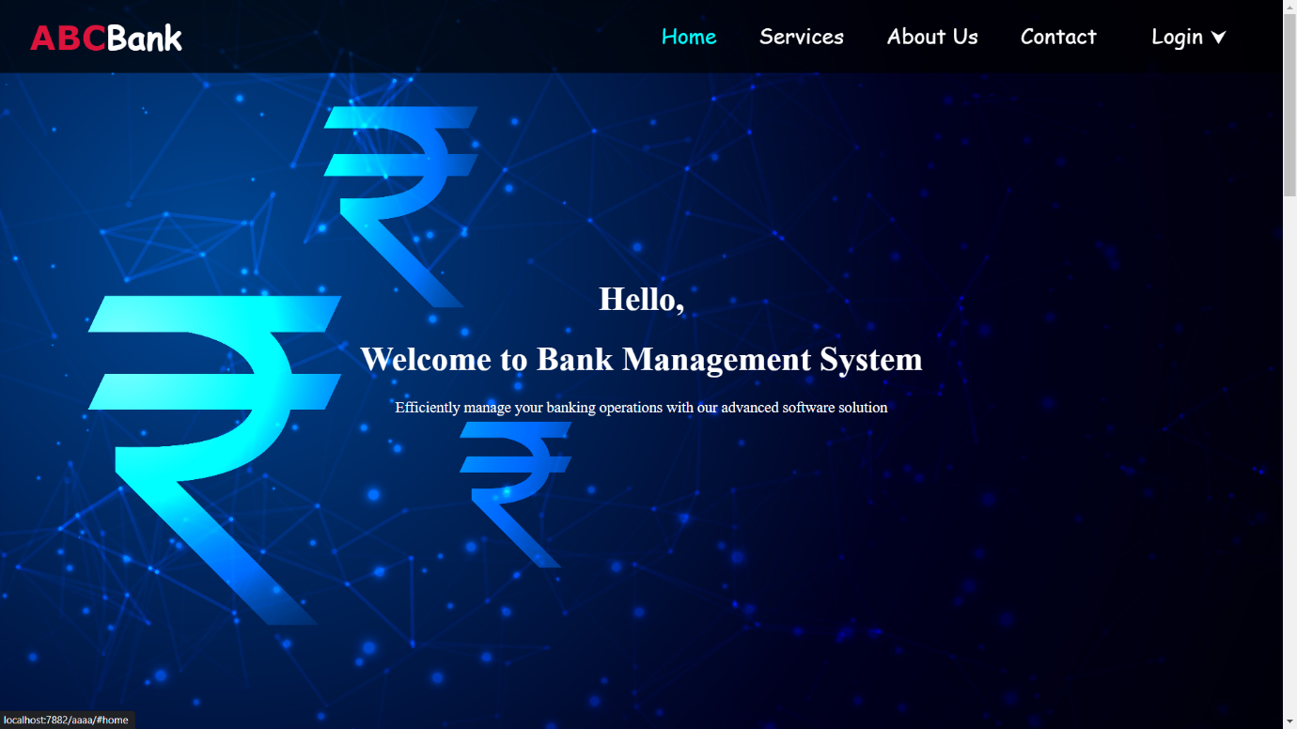

**Services Page**

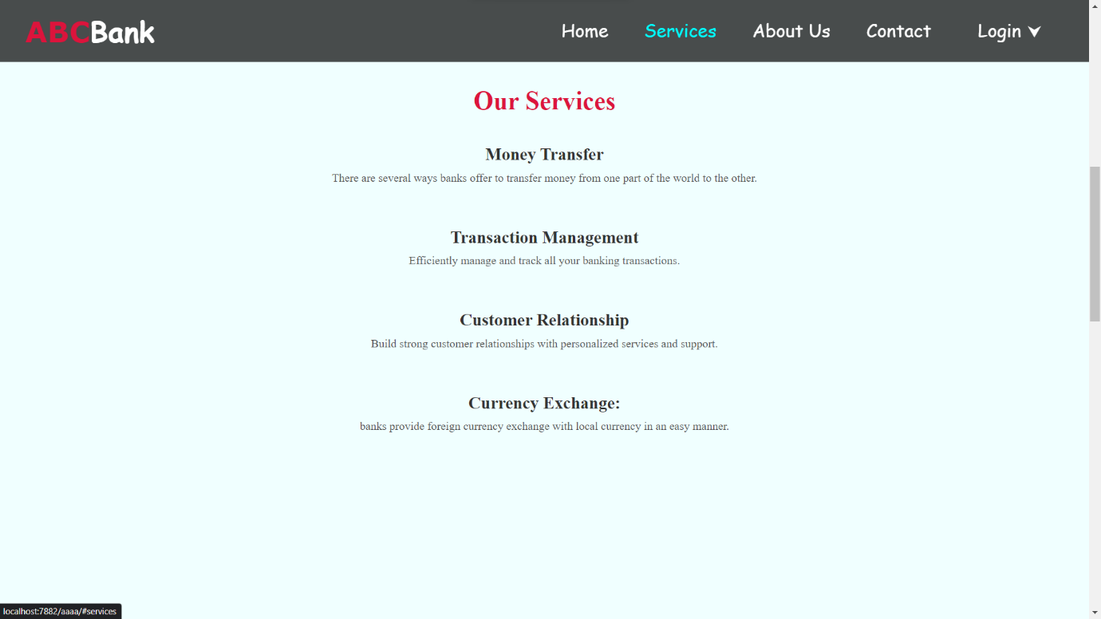

**About Us Page**

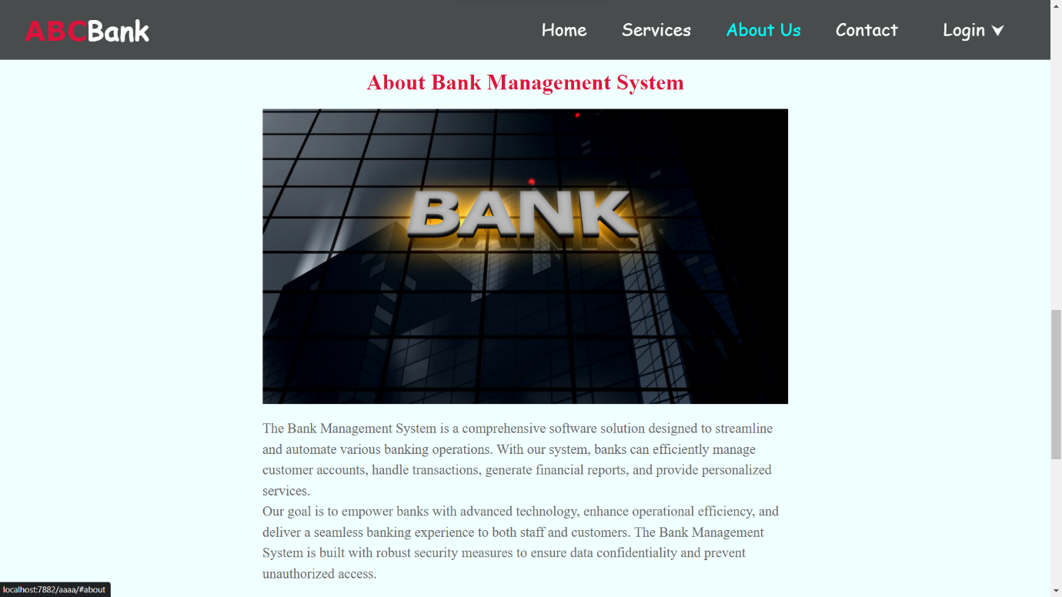

**Contact Page**

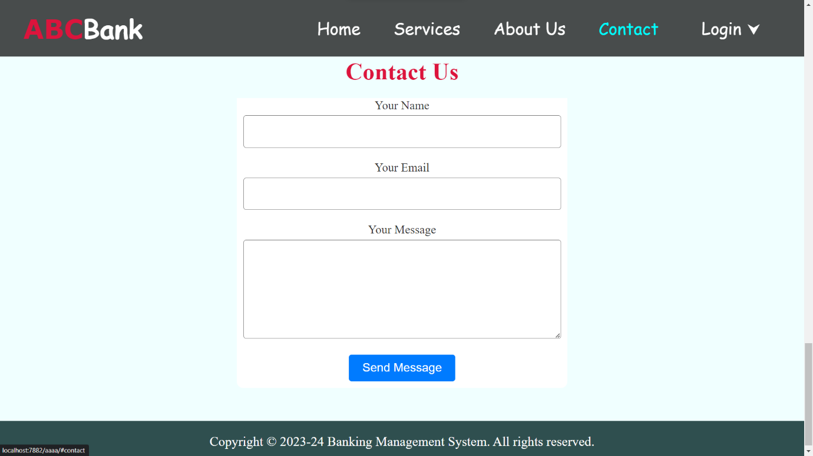

**User Login Page**

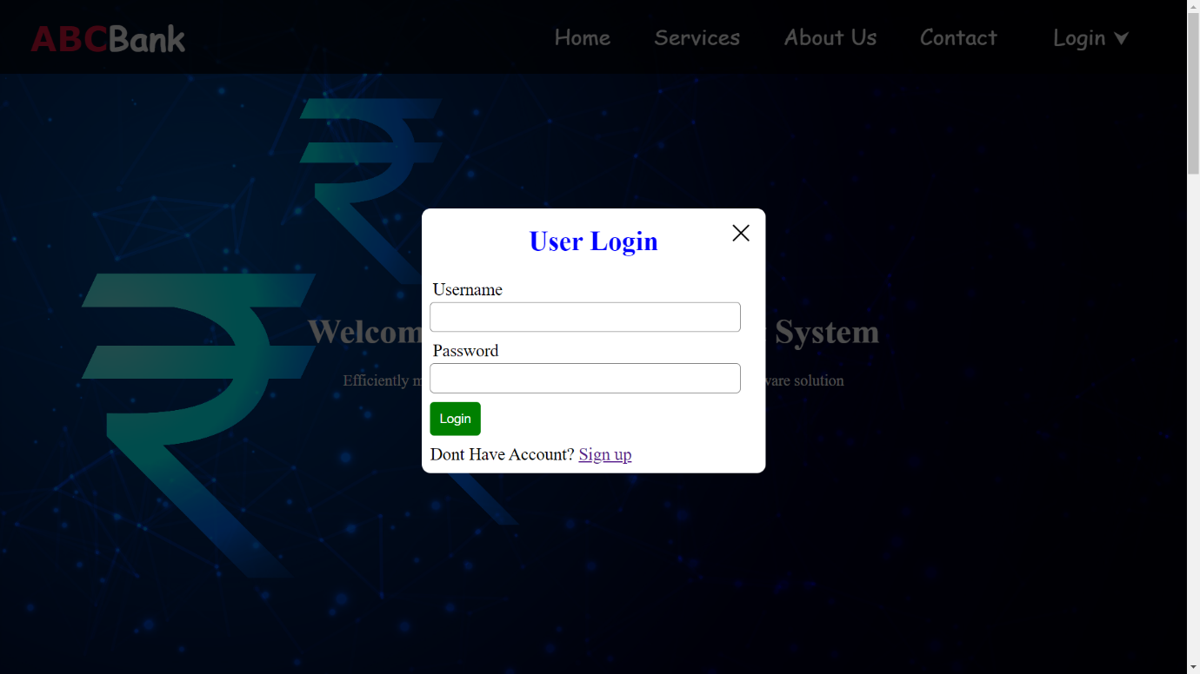

**User Sign Up Page**

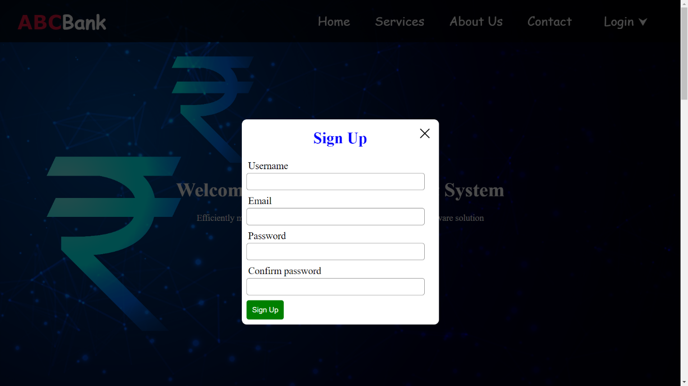

**Staff Login Page**

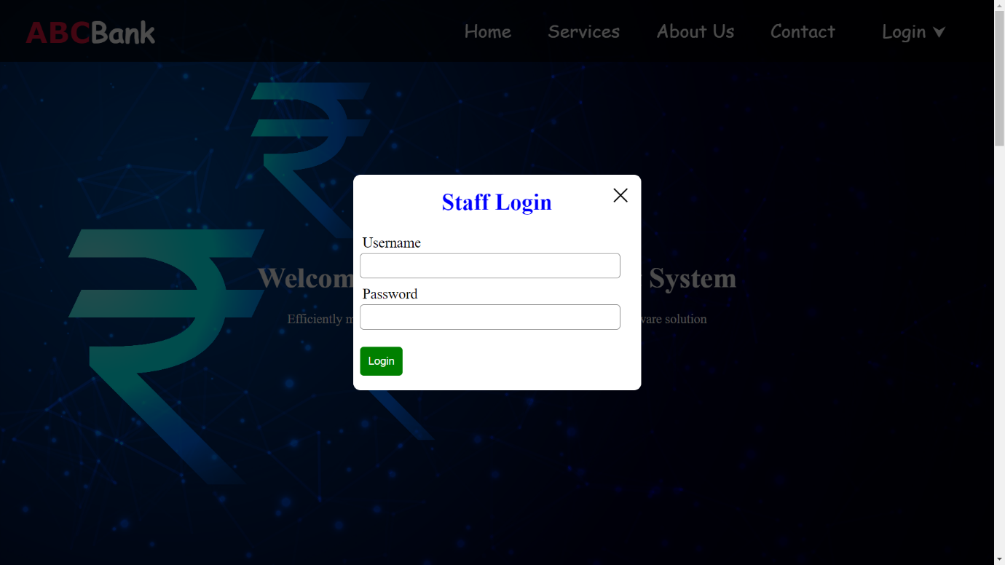

**Client**

**User Dashboard Page**

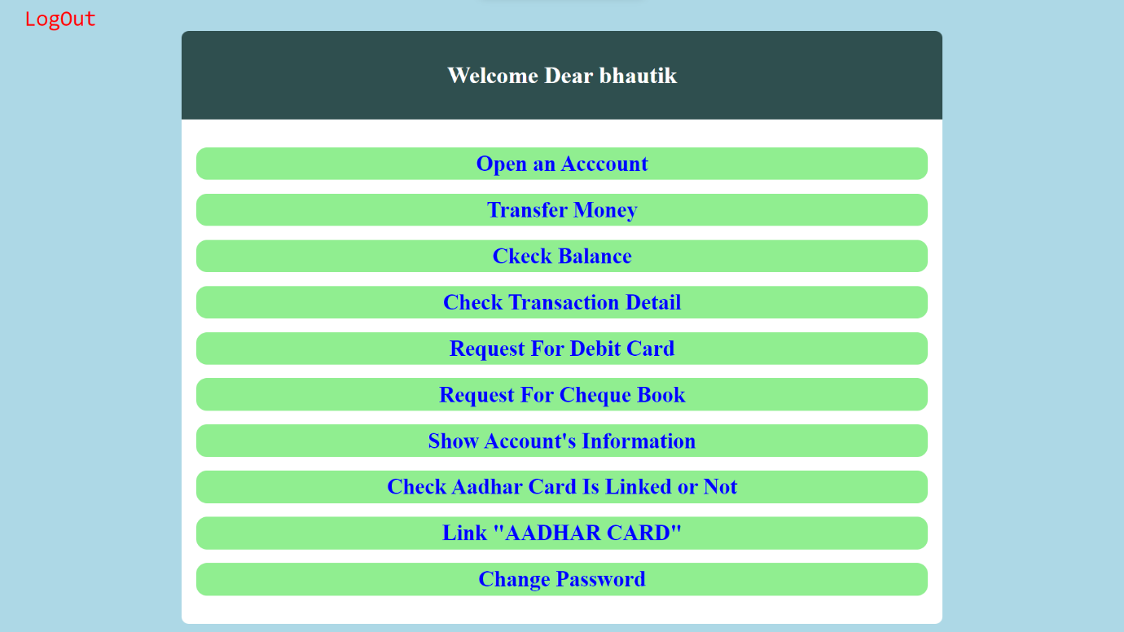

**Bank Account Open Page**

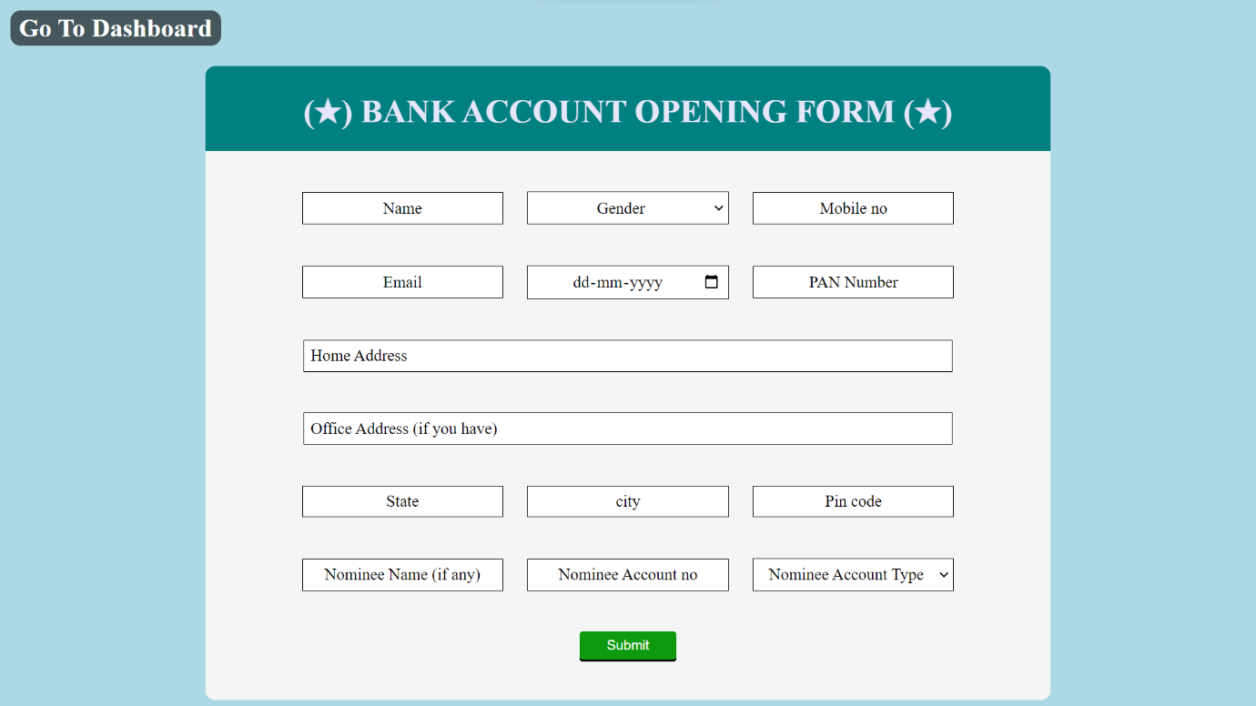

**Transfer Money Page**

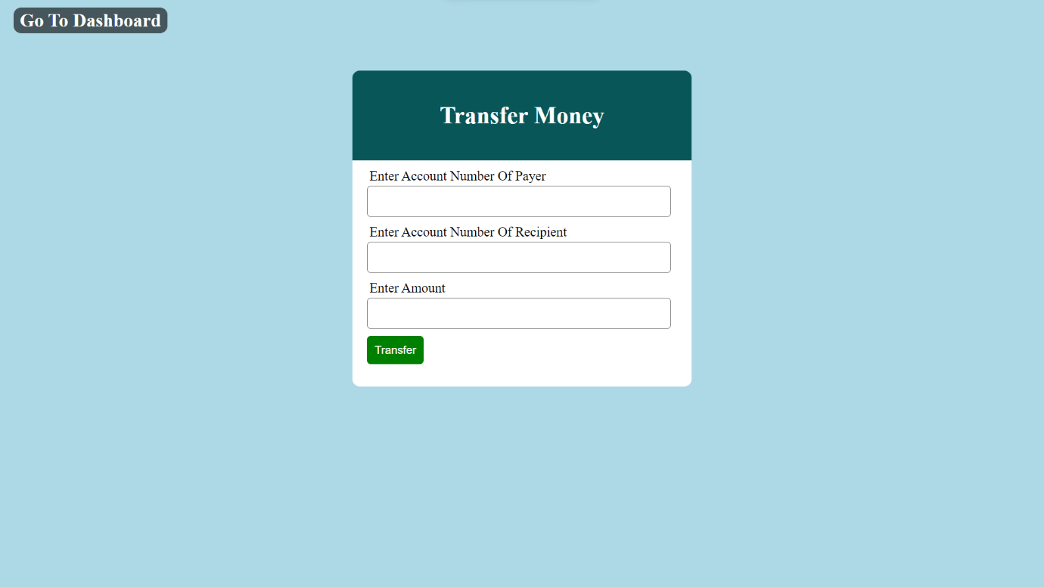

**Check Balance Page**

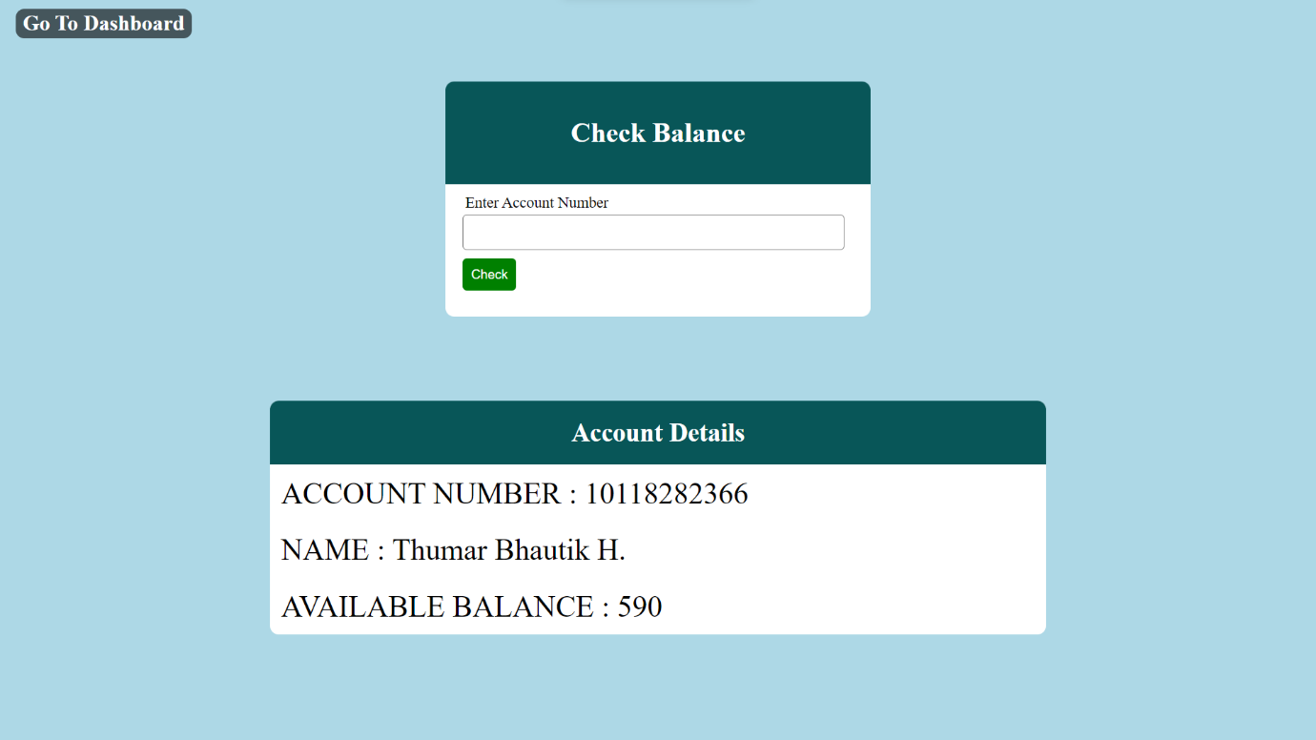

**Account Transaction’s Details Page**

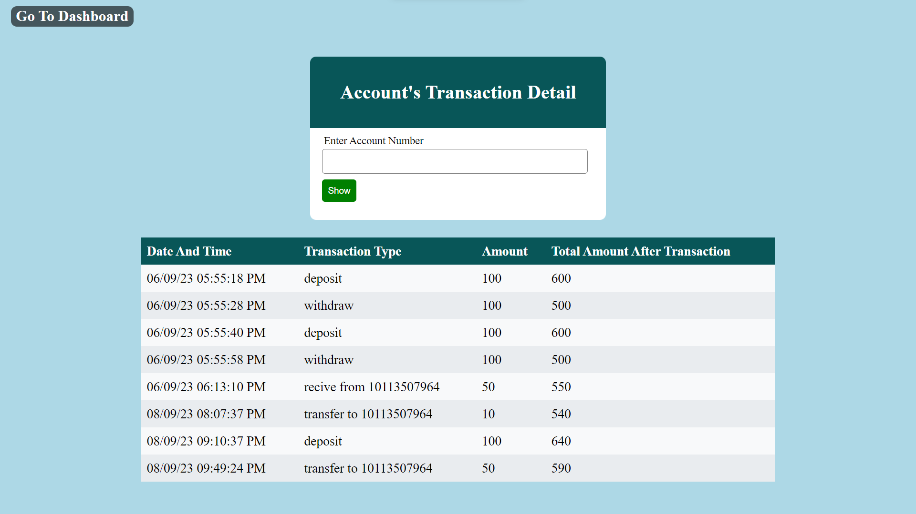

**Debit Card Request Page**



**Cheque Book Request Page**



**Aadhar Link Status Page**



**Aadhar Link Page**



**Account Information Page**

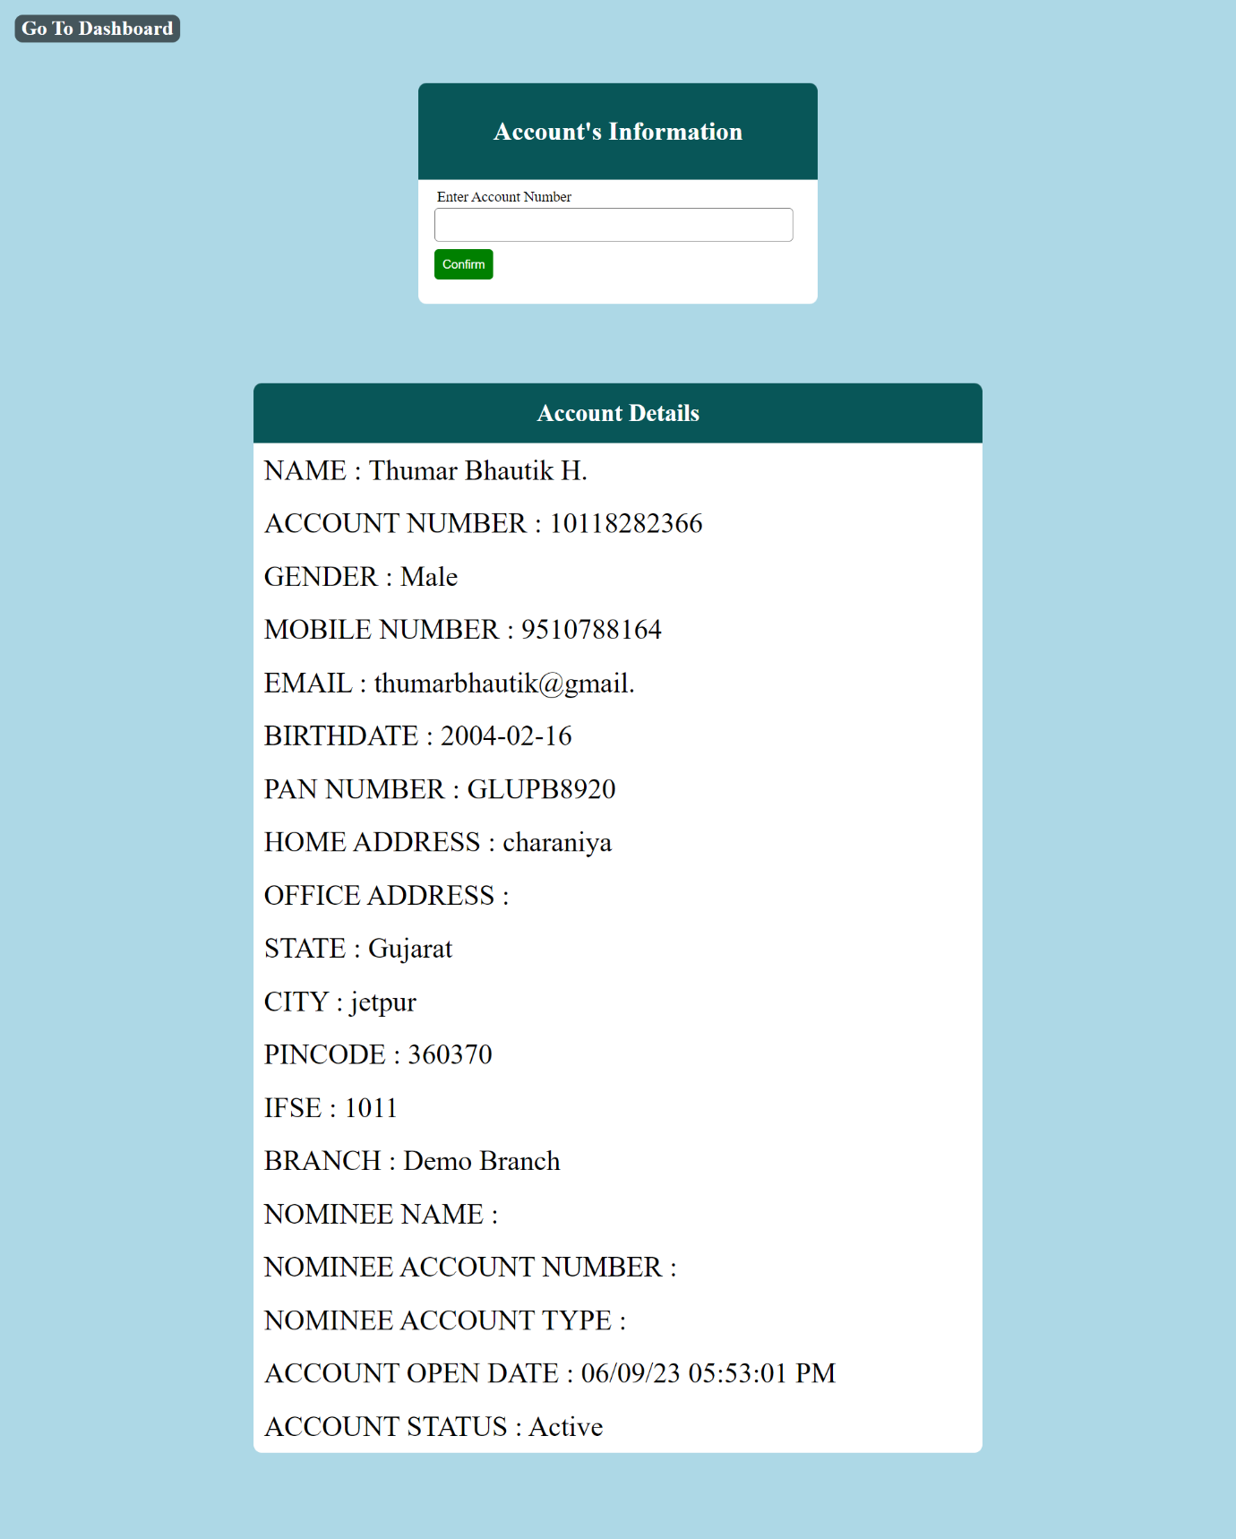

**Change Password Page**

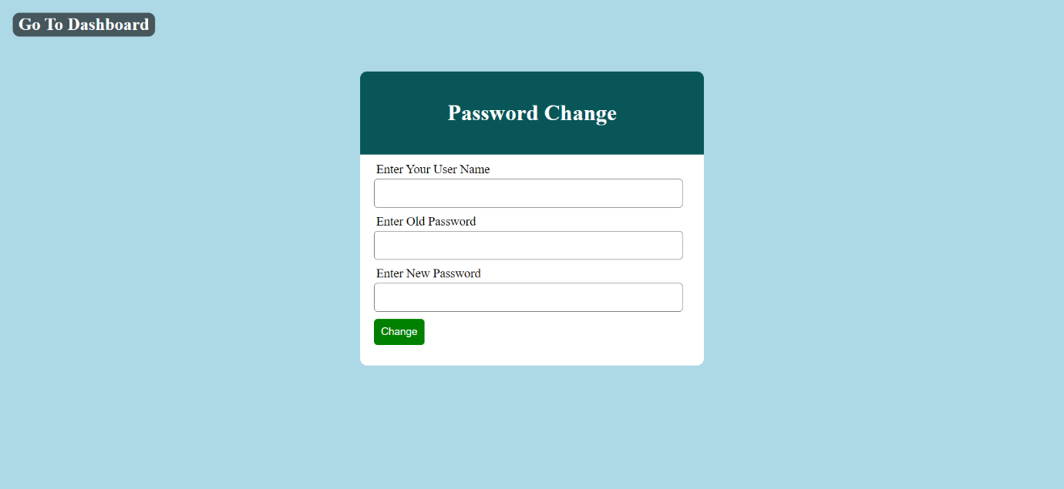

**Admin**

**Staff Dashboard Page**

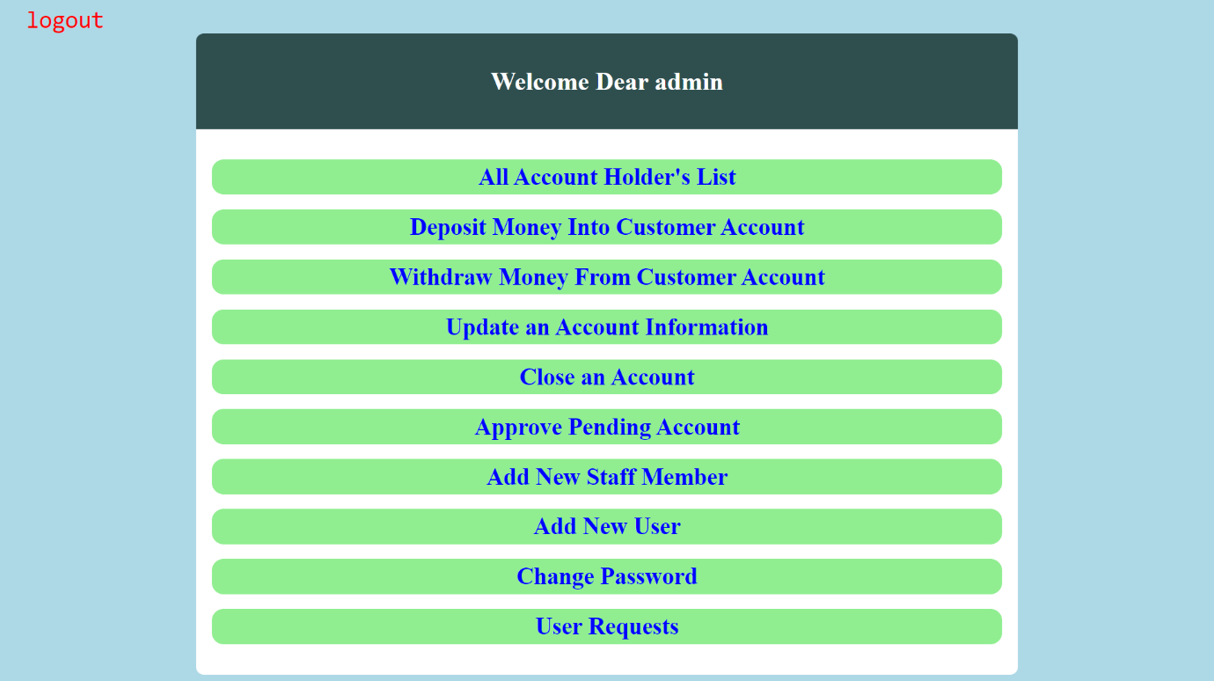**All Account List Page**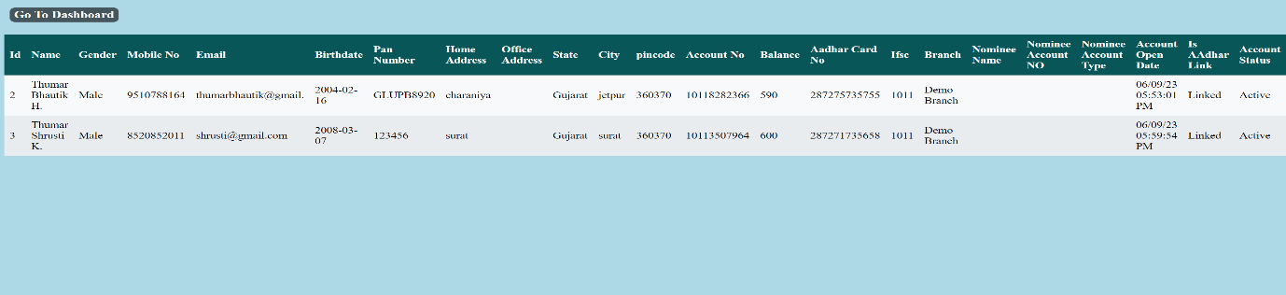

**Deposit Money Page**



**Withdraw Money Page**



**Close Account Page**



**User Requests Page**

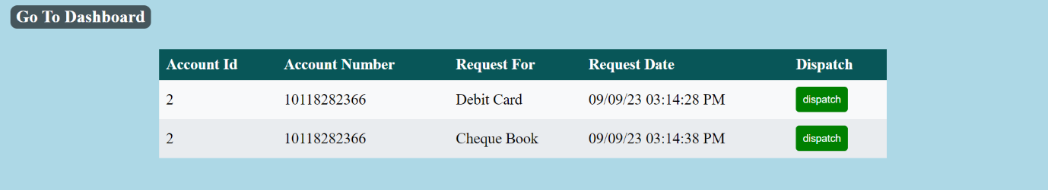

**Update Account Page**

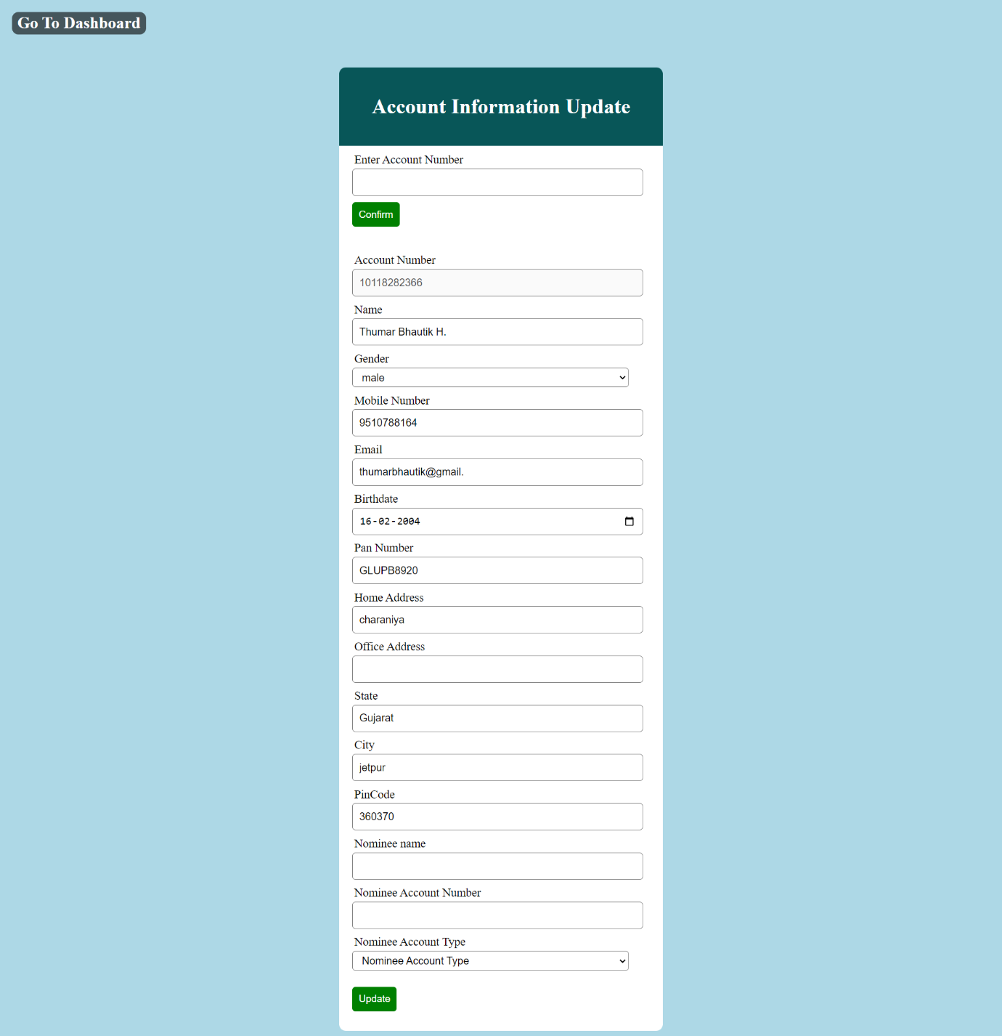

**Add New Staff Page**

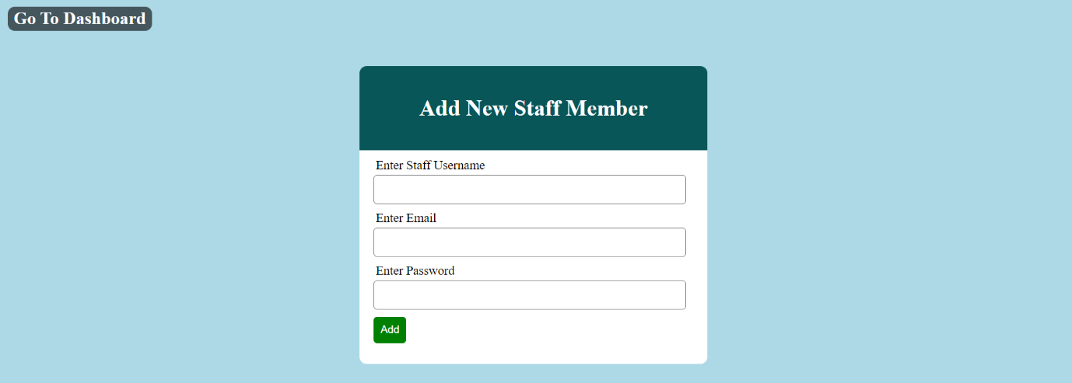

**Approve Account Page**

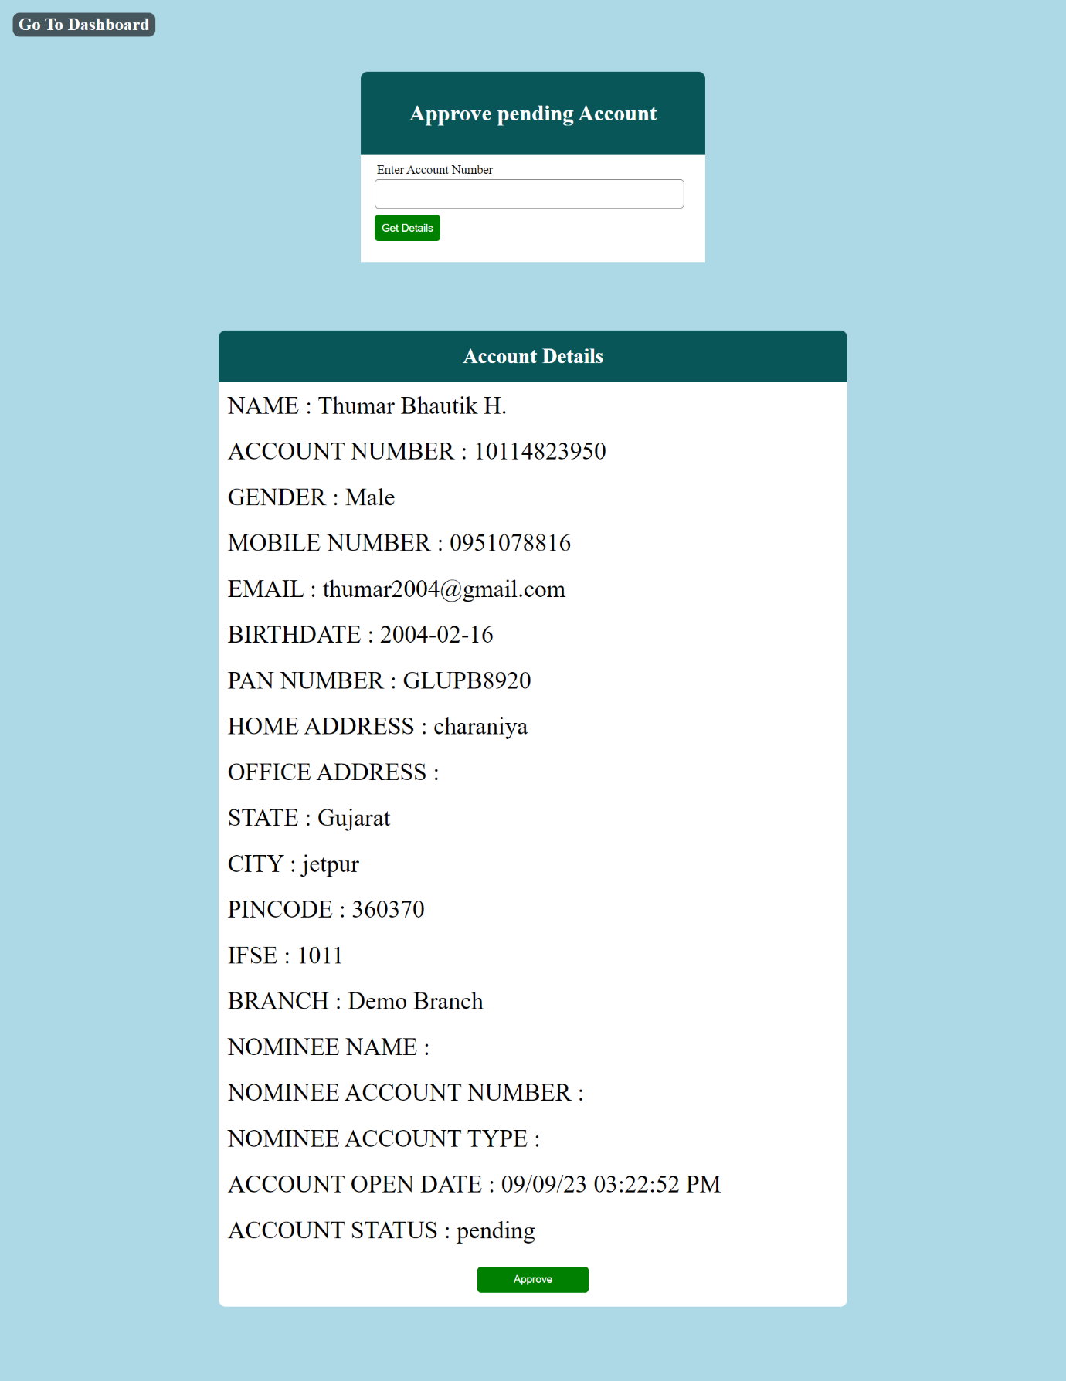

**Add New User Page**

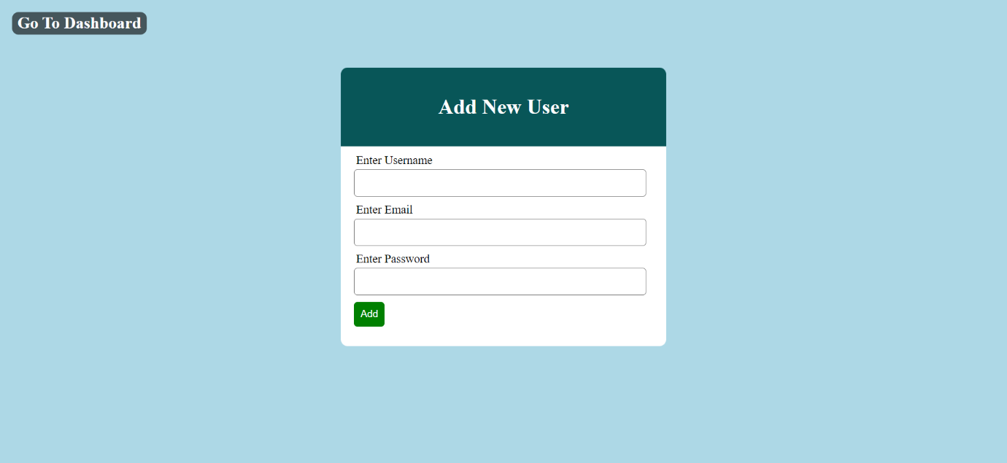

**Change Password Page**



* **Coding :-**
* **Index.php**

<?php

session_start();

?>

<!DOCTYPE html>

<html lang="en">

<head>

<meta charset="UTF-8">

<meta http-equiv="X-UA-Compatible" content="IE=edge">

<meta name="viewport" content="width=, initial-scale=1.0">

<title>Bank Manahemenet System</title>

<script src="js/jquery-1.9.1.min.js"></script>

<script src="js/ajaxscript.js"></script>

<link rel="stylesheet" href="css/style.css">

</head>

<body>

<div class="home" id="home">

<?php include './include/header.php'?>

<?php include './include/herosection.php'?>

<?php include './include/loginsignupform.php'?>

<?php include './include/services.php'?>

<?php include './include/about.php'?>

<?php include './include/contactus.php'?>

<?php include './include/footer.php'?>

<script src="js/script.js"></script>

<script>

var isuserlogin = "<?php

if (isset($_SESSION['user'])) {

echo "set";

} else {

echo "notset";

}

?>";

if (isuserlogin == "set") {

var heading = document.getElementById("userlogin");

heading.setAttribute("href", "action/useraction.php");

}

var isuserlogin = "<?php

if (isset($_SESSION['suser'])) {

echo "set";

} else {

echo "notset";

}

                ?>";

        if (isuserlogin == "set") {

            var heading = document.getElementById("stafflogin");

            heading.setAttribute("href", "action/staffaction.php");

        }

        </script>

</div>

</body>

</html>

* **header.php**

<div id="header">

    <div class="logo">

        <h1><span>ABC</span>Bank</h1>

    </div>

    <p class="menu" onclick="toggleNavbar()">&#8801;</p>

        <nav class="navbar" id="navbar">

            <ul class="navbar-nav">

                <li class="nav-item">

                    <a href="#home" class="nav-link">Home</a>

                </li>

                <li class="nav-item">

                    <a href="#services" class="nav-link" onclick="service()">Services</a>

                </li>

                <li class="nav-item">

                    <a href="#about" class="nav-link" onclick="about()">About Us</a>

                </li>

                <li class="nav-item">

                    <a href="#contact" class="nav-link" onclick="contact()">Contact</a>

                </li>

                <li class="nav-item dropdown">

                    <a href="#login" id="loginbtn" class="nav-link dropdown-toggle">Login &#11167;</a>

                    <ul class="dropdown-menu">

                        <li><a href="#" name="userlogin" id="userlogin">User Login</a></li>

                        <li><a href="#" name="stafflogin" id="stafflogin">Staff Login</a></li>

                    </ul>

                </li>

            </ul>

        </nav>

</div>

* **herosection.php**

<div class="hero">

    <h1>Hello,</h1>

    <h1>Welcome to Bank Management System</h1>

    <p>Efficiently manage your banking operations with our advanced software solution</p>

</div>

* **loginsignupform.php**

<div id="bg-modal" class="bg-modal">

    <div class="modal-content">

        <div class="header">

            <div class="close">+</div>

            <h1 id="heading">User Login</h1>

        </div>

        <form id="loginform" method="post">

            <div class="input">

                <label>Username</label>

                <input type="text" name="user" id="user">

            </div>

            <div class="input">

                <label>Password</label>

                <input type="password" name="pwd" id="pwd">

            </div>

            <div class="input">

                <button type="submit" class="btn" id="btn" name="userlogin">Login</button>

            </div>

            <p>

                Dont Have Account? <a id="user_add" href="#">Sign up</a>

            </p>

        </form>

        <form id="signupform" method="post">

            <div class="input">

                <label>Username</label>

                <input type="text" name="username" id="username" required>

            </div>

            <div class="input">

                <label>Email</label>

                <input type="email" name="semail" id="semail" required>

            </div>

            <div class="input">

                <label>Password</label>

                <input type="password" name="password" id="password">

            </div>

            <div class="input">

                <label>Confirm password</label>

                <input type="password" name="cpassword" id="cpassword">

            </div>

            <div class="input-group">

                <button type="submit" class="signupbtn" id="signupbtn" name="signup">Sign Up</button>

            </div>

        </form>

        <form id="stafffrom" method="post">

            <div class="input">

                <label>Username</label>

                <input type="text" name="suser" id="suser">

            </div>

            <div class="input">

                <label>Password</label>

                <input type="password" name="spwd" id="spwd">

            </div>

            <div style="padding:2px"></div>

            <div class="input">

                <button type="submit" class="sbtn" id="sbtn" name="stafflogin">Login</button>

            </div>

        </form>

    </div>

</div>

* **services.php**

<div class="services" id="services">

    <div class="container">

        <h2>Our Services</h2>

        <div class="service-item">

            <h3>Money Transfer</h3>

            <p>There are several ways banks offer to transfer money from one part of the world to the other.</p>

        </div>

        <div class="service-item">

            <h3>Transaction Management</h3>

            <p>Efficiently manage and track all your banking transactions.</p>

        </div>

        <div class="service-item">

            <h3>Customer Relationship</h3>

            <p>Build strong customer relationships with personalized services and support.</p>

        </div>

        <div class="service-item">

            <h3>Currency Exchange:</h3>

            <p>banks provide foreign currency exchange with local currency in an easy manner.</p>

        </div>

    </div>

</div>

* **about.php**

<div class="about" id="about">

    <h1 class="aboutheading">About Bank Management System</h1>

    <img src="images/bankk.png" alt="Company Image">

    <p>The Bank Management System is a comprehensive software solution designed to streamline and automate

        various

        banking operations. With our system, banks can efficiently manage customer accounts, handle

        transactions,

        generate financial reports, and provide personalized services.

    </p>

    <p>Our goal is to empower banks with advanced technology, enhance operational efficiency, and deliver a

        seamless banking experience to both staff and customers. The Bank Management System is built with robust

        security measures to ensure data confidentiality and prevent unauthorized access.

    </p>

</div>

* **contactus.php**

<div class="contact" id="contact">

    <div class="container">

        <h2>Contact Us</h2>

        <div class="contactform">

            <form id="formdata" method="post" action="./action/contact_us.php">

                <div class="formfield">

                    <label for="name">Your Name</label>

                    <input type="text" id="name" name="name" required>

                </div>

                <div class="formfield">

                    <label for="email">Your Email</label>

                    <input type="email" id="email" name="email" required>

                </div>

                <div class="formfield">

                    <label for="message">Your Message</label>

                    <textarea id="message" name="message" required></textarea>

                </div>

                <input type="submit" name="send" class="cbtn" value="Send Message">

            </form>

        </div>

    </div>

</div>

* **Contact_us.php**

<?php

include 'db_connect.php';

@$name = $_POST['name'];

@$email = $_POST['email'];

@$message = $_POST['message'];

$q = mysqli_query($con, "INSERT INTO contact_us (name  , email , message ) VALUES('$name' , '$email' , '$message')");

if ($q) {

    echo '<script>alert("Message Send Successfully")

        location="../index.php"

        </script>';

} else {

    echo "Error";

}

* **footer.php**

<div class="copyright">

    <p>Copyright © 2023-24 Banking Management System. All rights reserved.</p>

</div>

* **ajaxscript.js**

$(document).ready(function () {

  $("#btn").click(function (e) {

    console.log("clicked");

    var user = $("#user").val();

    var pwd = $("#pwd").val();

    if (user != "" && pwd != "") {

      $.ajax({

        url: "action/userlogin.php",

        method: "POST",

        data: {

          user: user,

          pwd: pwd,

        },

        success: function (response) {

          if (response == "no") {

            // $("#loginform")[0].reset();

            $("#loginform").trigger("reset");

            alert("username and password is wrong");

          } else {

            window.location.href = "action/useraction.php";

          }

        },

      });

    } else {

      alert("Both Fields Are equired");

    }

    return false;

  });

  $("#sbtn").click(function (e) {

    var suser = $("#suser").val();

    var spwd = $("#spwd").val();

    if (suser != "" && spwd != "") {

      $.ajax({

        url: "action/stafflogin.php",

        method: "POST",

        data: {

          suser: suser,

          spwd: spwd,

        },

        success: function (response) {

          if (response == "no") {

            // $("#stafffrom")[0].reset();

            $("#stafffrom").trigger("reset");

            alert("username and password is wrong");

          } else {

            window.location.href = "action/staffaction.php";

          }

        },

      });

    } else {

      alert("Both Fields Are Required");

    }

    return false;

  });

  $("#signupbtn").click(function (e) {

    var username = $("#username").val();

    var semail = $("#semail").val();

    var password = $("#password").val();

    var cpassword = $("#cpassword").val();

    if (username != "" && semail != "" && password != "" && cpassword != "") {

      $.ajax({

        url: "action/user_add.php",

        method: "POST",

        data: {

          username: username,

          semail: semail,

          password: password,

          cpassword: cpassword,

        },

        success: function (response) {

          if (response == "PasswordNotSame") {

            alert("Both Password Must Be Same");

          } else if (response == "UsernameNotavAvailable") {

            $("#username").val("");

            alert("This Username Is Alredy Taken Change Your Username");

          } else if (response == "EmailNotavAvailable") {

            $("#semail").val("");

            alert("This Email Is Alredy Taken Change Your Email");

          } else if (response == "Sucess") {

            closeModal();

           $("#stafffrom").trigger("reset");

            alert("Signup Sucessfully Complete");

          } else {

            alert(response);

          }

        },

      });

    } else {

      alert("All Fields Are Required");

    }

    return false;

  });

});

* **script.js**

var x = document.getElementById("navbar");

function toggleNavbar() {

  if (x.style.display === "block") {

    x.style.display = "none";

  } else {

    x.style.display = "block";

  }

}

function service() {

  if (x.style.display === "block") {

    x.style.display = "none";

  }

}

function about() {

  if (x.style.display === "block") {

    x.style.display = "none";

  }

}

function contact() {

  if (x.style.display === "block") {

    x.style.display = "none";

  }

}

const modal = document.getElementById("bg-modal");

const loginopenModalBtn = document.getElementById("userlogin");

const signpopenModalBtn = document.getElementById("user_add");

const staffloginBtn = document.getElementById("stafflogin");

const closeModalBtn = document.querySelector(".close");

const signupform = document.getElementById("signupform");

const loginform = document.getElementById("loginform");

const staffform = document.getElementById("stafffrom");

function loginopenModal() {

  var newHeading = "User Login";

  var heading = document.getElementById("heading");

  heading.textContent = newHeading;

  modal.style.display = "flex";

  loginform.style.display = "block";

  signupform.style.display = "none";

  staffform.style.display = "none";

}

function signupopenModal() {

  var newHeading = "Sign Up";

  var heading = document.getElementById("heading");

  heading.textContent = newHeading;

  modal.style.display = "flex";

  loginform.style.display = "none";

  signupform.style.display = "block";

  staffform.style.display = "none";

}

function staffloginopenModal() {

  var newHeading = "Staff Login";

  var heading = document.getElementById("heading");

  heading.textContent = newHeading;

  modal.style.display = "flex";

  loginform.style.display = "none";

  signupform.style.display = "none";

  staffform.style.display = "block";

}

function closeModal() {

  modal.style.display = "none";

}

loginopenModalBtn.addEventListener("click", loginopenModal);

signpopenModalBtn.addEventListener("click", signupopenModal);

closeModalBtn.addEventListener("click", closeModal);

staffloginBtn.addEventListener("click", staffloginopenModal);

* **db_connect.php**

<?php

$servername = "localhost";

$username = "root";

$password = "";

$database = "bank_project";

// Create connection

$con = new mysqli($servername, $username, $password, $database);

// Check connection

if (!$con) {

    echo "error";

}

* **user_add.php**

<?php

include "db_connect.php";

@$uname = $_POST["username"];

@$email = $_POST["semail"];

if (isset($_POST["username"])) {

    @$password = $_POST["password"];

    @$cpassword = $_POST["cpassword"];

    if ($password != $cpassword) {

        echo "PasswordNotSame";

    } else {

        $con = mysqli_connect("localhost", "root", "", "bank_project");

        $res = mysqli_query($con, "SELECT * FROM user_login WHERE username = '$uname'");

        $ress = mysqli_query($con, "SELECT * FROM user_login WHERE email = '$email'");

        if (mysqli_num_rows($res) > 0) {

            echo "UsernameNotavAvailable";

        } elseif (mysqli_num_rows($ress) > 0) {

            echo "EmailNotavAvailable";

        } else {

            $sql = "INSERT INTO user_login(username , email , password , cpassword  ) VALUES('$uname' , '$email' , '$password' , '$cpassword' )";

            if (mysqli_query($con, $sql)) {

                echo "Sucess";

            }

        }

    }

}

mysqli_close($con);

* **userlogin.php**

<?php

include 'db_connect.php';

session_start();

@$username = $_POST['user'];

@$password = $_POST['pwd'];

if (isset($_SESSION['user'])) {

    header("Location:useraction.php");

} else {

    if (isset($_POST['user'])) {

        $res = mysqli_query($con, "SELECT * FROM user_login WHERE username = '$username' AND password='$password'");

        if (mysqli_num_rows($res) > 0) {

            $_SESSION['user'] = $username;

            echo "success";

        } else {

            echo "no";

        }

    }

}

mysqli_close($con);

* **userlogout.php**

<?php

    session_start();

    include 'db_connect.php';

    unset($_SESSION['user']);

    header('location: ../index.php');

?>

* **staffogin.php**

<?php

include 'db_connect.php';

session_start();

@$username = $_POST['suser'];

@$password = $_POST['spwd'];

if (isset($_SESSION['suser'])) {

    header("Location:staffaction.php");

} else {

    if (isset($_POST['suser'])) {

        $res = mysqli_query($con, "SELECT * FROM staff_login WHERE username = '$username' AND password='$password'");

        if (mysqli_num_rows($res) > 0) {

            $_SESSION['suser'] = $username;

            echo "success";

        } else {

            echo "no";

        }

    }

}

mysqli_close($con);

* **stafflogout.php**

<?php

    session_start();

    include 'db_connect.php';

    // session_unset();

    // session_destroy();

    unset($_SESSION['suser']);

    header('location:../index.php');

?>

* **useraction.php**

<?php

session_start();

if(!isset($_SESSION['user'])){

  header("Location:../index.php");

}

?>

<!DOCTYPE html>

<html lang="en">

<head>

    <meta charset="UTF-8">

    <meta http-equiv="X-UA-Compatible" content="IE=edge">

    <meta name="viewport" content="width=device-width, initial-scale=1.0">

    <title>User Dashboard</title>

    <link rel="stylesheet" href="../css/useraction.css">

</head>

<body>

    <a href="userlogout.php" class="logout">LogOut</a>

    <div class="header">

        <h1> Welcome Dear <?php echo $_SESSION['user']; ?> </h1>

    </div>

    <div class="container">

        <h3><a href="accountopen.php"> Open an Acccount</a></h3>

        <h3><a href="transfer.php"> Transfer Money</a></h3>

        <h3><a href="check_balance.php"> Ckeck Balance</a></h3>

        <h3><a href="transaction.php"> Check Transaction Detail</a></h3>

        <h3><a href="debit_request.php"> Request For Debit Card</a></h3>

        <h3><a href="chequebook_request.php"> Request For Cheque Book</a></h3>

        <h3><a href="info.php"> Show Account's Information</a></h3>

        <h3><a href="aadhar_link_status.php">Check Aadhar Card Is Linked or Not</a></h3>

        <h3><a href="aadhar_link.php">Link "AADHAR CARD"</a></h3>

        <h3><a href="password_change.php">Change Password</a></h3>

    </div>

</body>

</html>

* **staffaction.php**

<?php

session_start();

if(!isset($_SESSION['suser'])){

  header("Location:../index.php");

}

?>

<!DOCTYPE html>

<html lang="en">

<head>

    <meta charset="UTF-8">

    <meta http-equiv="X-UA-Compatible" content="IE=edge">

    <meta name="viewport" content="width=device-width, initial-scale=1.0">

    <title>Staff Dashboard</title>

    <link rel="stylesheet" href="../css/useraction.css">

</head>

<body>

    <a href="stafflogout.php" class="logout">logout</a>

    <div class="header">

        <h1> Welcome Dear <?php echo $_SESSION['suser']; ?> </h1>

    </div>

    <div class="container">

        <h3><a href="account_list.php"> All Account Holder's List </a></h3>

        <h3><a href="deposit.php"> Deposit Money Into Customer Account</a></h3>

        <h3><a href="withdraw.php"> Withdraw Money From Customer Account</a></h3>

        <h3><a href="updateinfo.php">Update an Account Information</a></h3>

        <h3><a href="account_close.php"> Close an Account</a></h3>

        <h3><a href="account_approve.php">Approve Pending Account</a></h3>

        <h3><a href="staff_add.php"> Add New Staff Member</a></h3>

        <h3><a href="useradd.php"> Add New User</a></h3>

        <h3><a href="staffpassword_change.php">Change Password</a></h3>

        <h3><a href="userrequests.php"> User Requests </a></h3>

    </div>

</body>

</html>

* **accountopen.php**

<?php

include 'db_connect.php';

if (isset($_POST['submit'])) {

    $name = $_POST['name'];

    $gender = $_POST['gender'];

    $mobile = $_POST['mobile'];

    $email = $_POST['email'];

    $birthdate = $_POST['birthdate'];

    $pan_number = $_POST['pan_number'];

    $home_address = $_POST['home_address'];

    $office_address = $_POST['office_address'];

    $state = $_POST['state'];

    $city = $_POST['city'];

    $pincode = $_POST['pincode'];

    $nominee_name = $_POST['nominee_name'];

    $nominee_account = $_POST['nominee_account'];

    @$nominee_account_type = $_POST['nominee_account_type'];

    $ifsc = 1011;

    $Customer_ID = rand(1000, 9999);

    $branch = "Demo Branch";

    $account_no = $ifsc . rand(100, 999) . $Customer_ID;

    date_default_timezone_set('Asia/Kolkata');

    $acc_open_date = date("d/m/y h:i:s A");

    $res = mysqli_query($con, "INSERT INTO account_open (name , gender , mobile , email , birthdate , pan_number , home_address , office_address , state , city , pincode , account_no , ifsc , branch , nominee_name , nominee_account_number , nominee_account_type , acc_open_date , account_status ) VALUES('$name' , '$gender' , '$mobile' , '$email' , '$birthdate' , '$pan_number' , '$home_address' , '$office_address' , '$state' , '$city' , '$pincode' , '$account_no' , '$ifsc' , '$branch' , '$nominee_name' , '$nominee_account' , '$nominee_account_type' , '$acc_open_date' , 'pending' )");

    if ($res) {

        echo '<script>alert("Application submitted successfully\n\Account number : ' . $account_no . '\n\nPlease visit bank with this Account number for account approval\n Within 15 Days")

                location="useraction.php"

              </script>';

    } else {

        echo "Error";

    }

}

?>

<!DOCTYPE html>

<html lang="en">

<head>

    <meta charset="UTF-8">

    <meta http-equiv="X-UA-Compatible" content="IE=edge">

    <meta name="viewport" content="width=device-width, initial-scale=1.0">

    <title>Open Account</title>

    <script src="../js/validateform.js"></script>

    <link href="../css/bank.css" rel="stylesheet">

</head>

<body>

    <div class="dashboardlink">

        <a href="useraction.php">Go To Dashboard</a>

    </div>

    <div class="header">

        <h1> (★) BANK ACCOUNT OPENING FORM (★)</h1>

    </div>

    <form method="post" align="center" action="<?php $_SERVER['PHP_SELF'];?>" onsubmit="return validateForm()">

        <input type="text" name="name" id="name" class="a" placeholder="Name">

        <select name="gender" id="gender" class="a">

            <option value="" disabled selected>Gender</option>

            <option value="Male">male</option>

            <option value="Female">female</option>

            <option value="Other">other</option>

        </select>

        <input type="text" name="mobile" id="mobile" class="a" placeholder="Mobile no"><br>

        <input type="email" name="email" id="email" class="b" placeholder="Email">

        <input placeholder="Date Of Birth" class="b" type="text" onfocus="(this.type='date')" id="birthdate" />

        <input type="text" name="pan_number" id="pan_number" class="b" placeholder="PAN Number"><br>

        <input type="text" name="home_address" id="home_address" class="c" placeholder="Home Address"><br>

        <input type="text" name="office_address" id="office_address" class="c"

            placeholder="Office Address (if you have)"><br>

        <input type="text" name="state" id="state" class="b" placeholder="State">

        <input type="text" name="city" id="city" class="b" placeholder="city">

        <input type="text" name="pincode" id="pincode" class="b" placeholder="Pin code"><br>

        <input type="text" name="nominee_name" id="nominee_name" class="b" placeholder="Nominee Name (if any)">

        <input type="text" name="nominee_account" id="nominee_account" class="b" placeholder="Nominee Account no">

        <select name="nominee_account_type" id="nominee_account_type" class="b">

            <option disabled selected>Nominee Account Type</option>

            <option>Saving</option>

            <option>Current</option>

        </select><br>

        <input type="submit" name="submit" class="d" value="Submit">

    </form>

</body>

</html>

* **validateform.js**

function validateForm() {

  const name = document.getElementById("name").value;

  const gender = document.getElementById("gender");

  const genderselect = gender.value;

  const mobile = document.getElementById("mobile").value;

  const email = document.getElementById("email").value;

  const birthdate = document.getElementById("birthdate").value;

  const pan_number = document.getElementById("pan_number").value;

  const state = document.getElementById("state").value;

  const city = document.getElementById("city").value;

  const home_address = document.getElementById("home_address").value;

  const pincode = document.getElementById("pincode").value;

  if (name == "") {

    alert("Please Enter Your name");

    return false;

  } else if (genderselect == "") {

    alert("Please Select Your Gender");

    return false;

  } else if (mobile == "") {

    alert("Please Enter Your Mobile Number");

    return false;

  } else if (email == "") {

    alert("Please Enter Your Email");

    return false;

  } else if (birthdate == "") {

    alert("Please Enter Your BirthDate");

    return false;

  } else if (pan_number == "") {

    alert("Please Enter Your Pan Number");

    return false;

  } else if (home_address == "") {

    alert("Please Enter Your Home Address");

    return false;

  } else if (state == "") {

    alert("Please Enter Your State Name");

    return false;

  } else if (city == "") {

    alert("Please Enter Your city Name");

    return false;

  } else if (pincode == "") {

    alert("Please Enter Your Pin Code");

    return false;

  } else {

    return true;

  }

}

* **transfer.php**

<?php

include 'db_connect.php';

@$payer_account_no = $_POST['paccont_number'];

@$recipient_account_no = $_POST['raccont_number'];

@$amount = $_POST['amount'];

if (isset($_POST['transfer'])) {

    $res = mysqli_query($con, "SELECT * FROM account_open WHERE account_no = '$payer_account_no' ");

    $ress = mysqli_query($con, "SELECT * FROM account_open WHERE account_no = '$recipient_account_no' ");

    if (mysqli_num_rows($res) > 0 && mysqli_num_rows($ress) > 0 && $payer_account_no != $recipient_account_no) {

        $row = mysqli_fetch_assoc($res);

        $roww = mysqli_fetch_assoc($ress);

        $payer_current_amount = $row['balance'];

        $recipient_current_amount = $roww['balance'];

        $pid = $row['id'];

        $rid = $roww['id'];

        $payer_final_amount = $payer_current_amount - $amount;

        @$recipient_final_amount = $recipient_current_amount + $amount;

        date_default_timezone_set('Asia/Kolkata');

        $done_at = date("d/m/y h:i:s A");

        if ($payer_final_amount <= 500) {

            echo '<script>

            alert("Not Enough Balance to Transfer...");

            </script>';

        } else {

            $insq = mysqli_query($con, "INSERT INTO transaction (id , account_no , transaction_type , amount , total_amount , done_at) VALUES ('$pid' , '$payer_account_no' , 'transfer to $recipient_account_no' , '$amount' , '$payer_final_amount' , '$done_at')");

            $insq2 = mysqli_query($con, "INSERT INTO transaction (id , account_no , transaction_type , amount , total_amount , done_at) VALUES ('$rid','$recipient_account_no' , 'recive from $payer_account_no' , '$amount' , '$recipient_final_amount' , '$done_at')");

            if ($insq && $insq2) {

                $sql = "UPDATE account_open SET balance = '$payer_final_amount' WHERE account_no = '$payer_account_no' ";

                $sqll = "UPDATE account_open SET balance = '$recipient_final_amount' WHERE account_no = '$recipient_account_no' ";

                if (mysqli_query($con, $sql)) {

                    if (mysqli_query($con, $sqll)) {

                        echo '<script>

                        alert(" Amount Has Been Transfered Successfully");

                        </script>';

                    }

                }

            }

        }

    } else {

        echo '<script>

        alert(" Please Enter Valid Account Number ");

        </script>';

    }

}

mysqli_close($con);

?>

<!DOCTYPE html>

<html lang="en">

<head>

    <meta charset="UTF-8">

    <meta http-equiv="X-UA-Compatible" content="IE=edge">

    <meta name="viewport" content="width=device-width, initial-scale=1.0">

    <title>Transfer Money</title>

    <link rel="stylesheet" href="../css/info.css">

</head>

<body>

    <div class="dashboardlink">

        <a href="useraction.php">Go To Dashboard</a>

    </div>

    <div class="header">

        <h1> Transfer Money</h1>

    </div>

    <form method="post" action="<?php echo $_SERVER['PHP_SELF']; ?>">

        <div class="input">

            <label>Enter Account Number Of Payer </label>

            <input type="text" name="paccont_number" class="a" required>

        </div>

        <div class="input">

            <label>Enter Account Number Of Recipient </label>

            <input type="text" name="raccont_number" class="a" required>

        </div>

        <div class="input">

            <label>Enter Amount </label>

            <input type="text" name="amount" class="a" required><br>

        </div>

        <div class="input">

            <button type="submit" name="transfer" class="btn">Transfer</button>

        </div>

    </form>

</body>

</html>

* **check_balance.php**

<!DOCTYPE html>

<html lang="en">

<head>

    <meta charset="UTF-8">

    <meta http-equiv="X-UA-Compatible" content="IE=edge">

    <meta name="viewport" content="width=device-width, initial-scale=1.0">

    <title>Check Balance</title>

    <link rel="stylesheet" href="../css/info.css">

</head>

<body>

    <div class="dashboardlink">

        <a href="useraction.php">Go To Dashboard</a>

    </div>

    <div class="header">

        <h1> Check Balance</h1>

    </div>

    <form method="post" action="<?php $_SERVER['PHP_SELF'];?>">

        <div class="input">

            <label>Enter Account Number </label>

            <input type="text" name="account_no" required>

        </div>

        <div class="input">

            <button type="submit" name="info" class="btn">Check</button>

        </div>

    </form>

    <?php

include 'db_connect.php';

@$account_no = $_POST['account_no'];

if (isset($_POST['info'])) {

    $res = mysqli_query($con, "SELECT * FROM account_open WHERE account_no = '$account_no' ");

    if (mysqli_num_rows($res) > 0) {

        while ($arr = mysqli_fetch_assoc($res)) {

            echo '<div class="view">

                <div class="details">

                <h2 class="heading">Account Details</h2>

                <label>ACCOUNT NUMBER : ' . $arr['account_no'] . '</label>

                <label>NAME : ' . $arr['name'] . '</label>

                <label>AVAILABLE BALANCE : ' . $arr['balance'] . '</label>

                </div>

                </div>';

        }

    } else {

        echo '<script>

            alert(" Please Enter Valid Account Number ")

            </script>';

    }

}

mysqli_close($con);

?>

</body>

</html>

* **transaction.php**

<!DOCTYPE html>

<html lang="en">

<head>

    <meta charset="UTF-8">

    <meta http-equiv="X-UA-Compatible" content="IE=edge">

    <meta name="viewport" content="width=device-width, initial-scale=1.0">

    <title>Accounts Transaction Detail</title>

    <link rel="stylesheet" href="../css/info.css">

</head>

<body>

    <div class="dashboardlink">

        <a href="useraction.php">Go To Dashboard</a>

    </div>

    <div class="header">

        <h1> Account's Transaction Detail </h1>

    </div>

    <form method="post" action="<?php $_SERVER['PHP_SELF'];?>">

        <div class="input">

            <label>Enter Account Number </label>

            <input type="text" name="account_no" required>

        </div>

        <div class="input">

            <button type="submit" name="info" class="btn">Show</button>

        </div>

    </form>

<?php

include 'db_connect.php';

@$account_no = $_POST['account_no'];

if (isset($_POST['info'])) {

    $res = mysqli_query($con, "SELECT * FROM transaction WHERE account_no = '$account_no' ");

    if (mysqli_num_rows($res) > 0) {

        ?>

    <table align="center">

        <tr>

            <th>Date And Time</th>

            <th>Transaction Type</th>

            <th>Amount</th>

            <th>Total Amount After Transaction </th>

        </tr>

        <?php

while ($arr = mysqli_fetch_row($res)) {

            echo "<tr><td>";

            echo $arr[5];

            echo "</td><td>";

            echo $arr[2];

            echo "</td><td>";

            echo $arr[3];

            echo "</td><td>";

            echo $arr[4];

            echo "</td>";

        }

        echo "</table>";

    } else {

        echo '<script>

                alert(" Please Enter Valid Account Number ")

                location = "transaction.php";

              </script>';

    }

}

mysqli_close($con);

?>

</body>

</html>

* **debit_request.php**

<?php

include 'db_connect.php';

@$account_no = $_POST['account_no'];

if (isset($_POST['confirm'])) {

    $res = mysqli_query($con, "SELECT * FROM account_open WHERE account_no = '$account_no' ");

    $ress = mysqli_query($con, "SELECT * FROM debit_request WHERE account_no = '$account_no' ");

    if (!mysqli_num_rows($ress) > 0) {

        if (!mysqli_num_rows($res) > 0) {

            echo '<script>

            alert(" Please Enter Valid Account Number ")

            </script>';

        } else {

            $row = mysqli_fetch_assoc($res);

            $id = $row['id'];

            date_default_timezone_set('Asia/Kolkata');

            $request_date = date("d/m/y h:i:s A");

            $resss = mysqli_query($con, "INSERT INTO debit_request (id, account_no,request_date) VALUES ('$id' , '$account_no' ,'$request_date') ");

            if ($resss) {

                echo '<script>

                    alert(" Your Request For Debit Card Successfully Send... \n Our Bank Will Send Your Debit Card with 10 or 15 At Your Address Day\n Through Post")

                    </script>';

            }

        }

    } else {

        echo '<script>

        alert("Your Request Has Alredy send..\n Please Wait Our Bank Will Send Your Debit Card Within Few Days..")

        </script>';

    }

}

mysqli_close($con);

?>

<!DOCTYPE html>

<html lang="en">

<head>

    <meta charset="UTF-8">

    <meta http-equiv="X-UA-Compatible" content="IE=edge">

    <meta name="viewport" content="width=device-width, initial-scale=1.0">

    <title>Request For Debit Card</title>

    <link rel="stylesheet" href="../css/info.css">

</head>

<body>

    <div class="dashboardlink">

        <a href="useraction.php">Go To Dashboard</a>

    </div>

    <div class="header">

        <h1>Request For Debit Card</h1>

    </div>

    <form method="post" action="<?php $_SERVER['PHP_SELF'];?>">

        <div class="input">

            <label>Enter Account Number </label>

            <input type="text" name="account_no" required>

        </div>

        <div class="input">

            <button type="submit" name="confirm" class="btn" value="Confirm">confirm</button>

        </div>

    </form>

</body>

</html>

* **chequebook_request.php**

<?php

include 'db_connect.php';

@$account_no = $_POST['account_no'];

if (isset($_POST['confirm'])) {

    $res = mysqli_query($con, "SELECT * FROM account_open WHERE account_no = '$account_no' ");

    $ress = mysqli_query($con, "SELECT * FROM chequebook_request WHERE account_no = '$account_no' ");

    if (!mysqli_num_rows($ress) > 0) {

        if (!mysqli_num_rows($res) > 0) {

            echo '<script>

                alert(" Please Enter Valid Account Number ")

                </script>';

        } else {

            $row = mysqli_fetch_assoc($res);

            $id = $row['id'];

            date_default_timezone_set('Asia/Kolkata');

            $request_date = date("d/m/y h:i:s A");

            $resss = mysqli_query($con, "INSERT INTO chequebook_request (id,account_no,request_date) VALUES ('$id','$account_no' ,'$request_date') ");

            if ($resss) {

                echo '<script>

                alert(" Your Request For Debit Card Successfully Send... \n Our Bank Will Send Your Cheque Book with 10 or 15 At Your Address Day\n Through Post")

                </script>';

            }

        }

    } else {

        echo '<script>

    alert("Your Request Has Alredy send..\n Please Wait Our Bank Will Send Your Cheque Book Within Few Days..")

    </script>';

    }

}

mysqli_close($con);

?>

<!DOCTYPE html>

<html lang="en">

<head>

    <meta charset="UTF-8">

    <meta http-equiv="X-UA-Compatible" content="IE=edge">

    <meta name="viewport" content="width=device-width, initial-scale=1.0">

    <title>Request For Cheque Book</title>

    <link rel="stylesheet" href="../css/info.css">

</head>

<body>

    <div class="dashboardlink">

        <a href="useraction.php">Go To Dashboard</a>

    </div>

    <div class="header">

        <h1> Request For Cheque Book</h1>

    </div>

    <form method="post" action="<?php $_SERVER['PHP_SELF'];?>">

        <div class="input">

            <label>Enter Account Number </label>

            <input type="text" name="account_no" required>

        </div>

        <div class="input">

            <button type="submit" name="confirm" class="btn">Confirm</button>

        </div>

    </form>

</body>

</html>

* **accountinfo.php**

<!DOCTYPE html>

<html lang="en">

<head>

    <meta charset="UTF-8">

    <meta http-equiv="X-UA-Compatible" content="IE=edge">

    <meta name="viewport" content="width=device-width, initial-scale=1.0">

    <title>Accounts Information</title>

    <link rel="stylesheet" href="../css/info.css">

</head>

<body>

    <div class="dashboardlink">

        <a href="useraction.php">Go To Dashboard</a>

    </div>

    <div class="header">

        <h1 align="center"> Account's Information </h1>

    </div>

    <form method="post" action="<?php $_SERVER['PHP_SELF'];?>">

        <div class="input">

            <label>Enter Account Number </label>

            <input type="text" name="account_no" required>

        </div>

        <div class="input">

            <button type="submit" name="info" class="btn">Confirm</button>

        </div>

    </form>

<?php

include 'db_connect.php';

@$account_no = $_POST['account_no'];

if (isset($_POST['info'])) {

    $res = mysqli_query($con, "SELECT * FROM account_open WHERE account_no = '$account_no' ");

    if (mysqli_num_rows($res) > 0) {

        while ($arr = mysqli_fetch_assoc($res)) {

            echo '<div class="view">

                <div class="details">

                <h2 class="heading">Account Details</h2>

                <label>NAME  : ' . $arr['name'] . '</label>

                <label>ACCOUNT NUMBER : ' . $arr['account_no'] . '</label>

                <label>GENDER : ' . $arr['gender'] . '</label>

                <label>MOBILE NUMBER : ' . $arr['mobile'] . '</label>

                <label>EMAIL : ' . $arr['email'] . '</label>

                <label>BIRTHDATE : ' . $arr['birthdate'] . '</label>

                <label>PAN NUMBER : ' . $arr['pan_number'] . '</label>

                <label>HOME ADDRESS : ' . $arr['home_address'] . '</label>

                <label>OFFICE ADDRESS : ' . $arr['office_address'] . '</label>

                <label>STATE : ' . $arr['state'] . '</label>

                <label>CITY : ' . $arr['city'] . '</label>

                <label>PINCODE : ' . $arr['pincode'] . '</label>

                <label>IFSE : ' . $arr['ifsc'] . '</label>

                <label>BRANCH : ' . $arr['branch'] . '</label>

                <label>NOMINEE NAME : ' . $arr['nominee_name'] . '</label>

                <label>NOMINEE ACCOUNT NUMBER : ' . $arr['nominee_account_number'] . '</label>

                <label>NOMINEE ACCOUNT TYPE : ' . $arr['nominee_account_type'] . '</label>

                <label>ACCOUNT OPEN DATE : ' . $arr['acc_open_date'] . '</label>

                <label>ACCOUNT STATUS : ' . $arr['account_status'] . '</label>

                </div>

                </div>';

        }

        mysqli_close($con);

    } else {

        echo '<script>

            alert(" Please Enter Valid Account Number ")

            </script>';

    }

}

?>

</body>

</html>

* **aadhar_link_status.php**

<?php

include 'db_connect.php';

@$account_no = $_POST['account_no'];

if (isset($_POST['confirm'])) {

    $res = mysqli_query($con, "SELECT * FROM account_open WHERE account_no = '$account_no' ");

    if (!mysqli_num_rows($res) > 0) {

        echo '<script>

        alert(" Please Enter Valid Account Number...")

        </script>';

    } else {

        $res2 = mysqli_query($con, "SELECT * FROM account_open WHERE account_no = '$account_no' And is_aadhar_link = 'Linked' ");

        if (!mysqli_num_rows($res2) > 0) {

            echo '<script>

            if(confirm("Aadhar Card Is Not Linked \n If You Want To Link Please Click On OK Button"))

            {

                location = "aadhar_link.php";

            }

            </script>';

        } else {

            echo '<script>

        alert(" Aadhar Card Is Linked")

        location = "useraction.php";

        </script>';

        }

    }

}

mysqli_close($con);

?>

<!DOCTYPE html>

<html lang="en">

<head>

    <meta charset="UTF-8">

    <meta http-equiv="X-UA-Compatible" content="IE=edge">

    <meta name="viewport" content="width=device-width, initial-scale=1.0">

    <title>Check Aadhar Card Is Linked or Not</title>

    <link rel="stylesheet" href="../css/info.css">

</head>

<body>

    <div class="dashboardlink">

        <a href="useraction.php"> Go To Dashboard</a>

    </div>

    <div class="header">

        <h1> Check Aadhar Linked Status</h1>

    </div>

    <form method="post" action="<?php $_SERVER['PHP_SELF'];?>">

        <div class="input">

            <label>Enter Account Number </label>

            <input type="text" name="account_no" required>

        </div>

        <div class="input">

            <button type="submit" name="confirm" class="btn">Confirm</button>

        </div>

    </form>

</body>

</html>

* **aadhar_link.php**

<?php

include 'db_connect.php';

@$account_no = $_POST['account_no'];

@$aadhar_card_no = $_POST['aadhar_card_no'];

if (isset($_POST['link'])) {

    $res = mysqli_query($con, "SELECT * FROM account_open WHERE account_no = '$account_no' ");

    if (!mysqli_num_rows($res) > 0) {

        echo '<script>

        alert(" Please Enter Valid Account Number ");

        location="aadhar_link.php";

        </script>';

    } else {

        $qry = "UPDATE account_open SET aadhar_card_no = '$aadhar_card_no' ,    is_aadhar_link = 'Linked' WHERE account_no = '$account_no' ";

        if (mysqli_query($con, $qry)) {

            echo '<script>

                     alert(" Aadhar Card Link Successfully");

                     </script>';

        }

    }

}

mysqli_close($con);

?>

<!DOCTYPE html>

<html lang="en">

<head>

    <meta charset="UTF-8">

    <meta http-equiv="X-UA-Compatible" content="IE=edge">

    <meta name="viewport" content="width=device-width, initial-scale=1.0">

    <title>Aadhar Card Link</title>

    <script src="../js/validateaadhar.js"></script>

    <link rel="stylesheet" href="../css/info.css">

</head>

<body>

    <div class="dashboardlink">

        <a href="useraction.php">Go To Dashboard</a>

    </div>

    <div class="header">

        <h1> Aadhar Card Link </h1>

    </div>

    <form method="post" action="<?php echo $_SERVER['PHP_SELF']; ?>" onsubmit="return validateaadhar()">

        <div class="input">

            <label>Enter Account Number </label>

            <input type="text" name="account_no" required>

        </div>

        <div class="input">

            <label> Enter Aadhar Card Number </label>

            <input type="text" name="aadhar_card_no" id="aadhar_card_no" required>

        </div>

        <div class="input">

            <button type="submit" name="link" class="btn">Confirm</button>

        </div>

    </form>

</body>

</html>

* **validateaadhar.js**

function validateaadhar() {

  var aadhaarNumber = document.getElementById("aadhar_card_no").value;

  if (validateAadhaarNumber(aadhaarNumber)) {

    return true;

  } else {

    alert("Invalid Aadhaar card number!");

    return false;

  }

}

function validateAadhaarNumber(aadhaarNumber) {

  // Aadhaar card number validation logic

  var aadhaarPattern = /^\d{12}$/;

  return aadhaarPattern.test(aadhaarNumber);

}

* **password_change.php**

<?php

include 'db_connect.php';

@$username = $_POST['username'];

@$opassword = $_POST['opassword'];

@$npassword = $_POST['npassword'];

if (isset($_POST['change'])) {

    $res = mysqli_query($con, "SELECT * FROM user_login WHERE username = '$username' AND password = '$opassword' ");

    if (!mysqli_num_rows($res) > 0) {

        echo '<script>

            alert(" Invalid Username Or Old Password  ");

            </script>';

    } else {

        @$npassword = $_POST['npassword'];

        $sql = "UPDATE user_login SET password = '$npassword' , cpassword = '$npassword'  WHERE username = '$username' ";

        if (mysqli_query($con, $sql)) {

            echo '<script>

            alert(" Password Change Successfully... ");

            </script>';

        }

    }

}

mysqli_close($con);

?>

<!DOCTYPE html>

<html lang="en">

<head>

    <meta charset="UTF-8">

    <meta http-equiv="X-UA-Compatible" content="IE=edge">

    <meta name="viewport" content="width=device-width, initial-scale=1.0">

    <title>Password Change</title>

    <link rel="stylesheet" href="../css/info.css">

</head>

<body>

    <div class="dashboardlink">

        <a href="useraction.php">Go To Dashboard</a>

    </div>

    <div class="header">

        <h1 align="center"> Password Change </h1>

    </div>

    <form method="post" action="<?php echo $_SERVER['PHP_SELF']; ?>">

        <div class="input">

            <label>Enter Your User Name </label>

            <input type="text" name="username" required align="center">

        </div>

        <div class="input">

            <label>Enter Old Password </label>

            <input type="text" name="opassword" required align="center">

        </div>

        <div class="input">

            <label>Enter New Password </label>

            <input type="text" name="npassword" required align="center"><br>

        </div>

        <div class="input">

            <button type="submit" name="change" align="center" class="btn">Change</button>

        </div>

    </form>

</body>

</html>

* **account_list.php**

<?php

include 'db_connect.php';

$res = mysqli_query($con, "select * from account_open");

?>

<!doctype html>

<html lang="en">

<head>

    <title>All Accounts List</title>

    <link rel="stylesheet" href="../css/info.css">

</head>

<body>

    <div class="dashboardlink">

        <a href="staffaction.php">Go To Dashboard</a>

    </div>

    <table>

        <tr>

            <th>Id</th>

            <th>Name</th>

            <th>Gender</th>

            <th>Mobile No</th>

            <th>Email</th>

            <th>Birthdate</th>

            <th>Pan Number</th>

            <th>Home Address</th>

            <th>Office Address</th>

            <th>State</th>

            <th>City</th>

            <th>pincode</th>

            <th>Account No</th>

            <th>Balance</th>

            <th>Aadhar Card No</th>

            <th>Ifsc</th>

            <th>Branch</th>

            <th>Nominee Name</th>

            <th>Nominee Account NO</th>

            <th>Nominee Account Type</th>

            <th>Account Open Date</th>

            <th>Is AAdhar Link</th>

            <th>Account Status</th>

        </tr>

        <?php while ($row = mysqli_fetch_assoc($res)) {?>

        <tr>

            <td><?php echo $row['id'] ?></td>

            <td><?php echo $row['name'] ?></td>

            <td><?php echo $row['gender'] ?></td>

            <td><?php echo $row['mobile'] ?></td>

            <td><?php echo $row['email'] ?></td>

            <td><?php echo $row['birthdate'] ?></td>

            <td><?php echo $row['pan_number'] ?></td>

            <td><?php echo $row['home_address'] ?></td>

            <td><?php echo $row['office_address'] ?></td>

            <td><?php echo $row['state'] ?></td>

            <td><?php echo $row['city'] ?></td>

            <td><?php echo $row['pincode'] ?></td>

            <td><?php echo $row['account_no'] ?></td>

            <td><?php echo $row['balance'] ?></td>

            <td><?php echo $row['aadhar_card_no'] ?></td>

            <td><?php echo $row['ifsc'] ?></td>

            <td><?php echo $row['branch'] ?></td>

            <td><?php echo $row['nominee_name'] ?></td>

            <td><?php echo $row['nominee_account_number'] ?></td>

            <td><?php echo $row['nominee_account_type'] ?></td>

            <td><?php echo $row['acc_open_date'] ?></td>

            <td><?php echo $row['is_aadhar_link'] ?></td>

            <td><?php echo $row['account_status'] ?></td>

        </tr>

        <?php }?>

    </table>

</body>

</html>

* **deposit.php**

<?php

include 'db_connect.php';

@$account_no = $_POST['account_no'];

@$amount = $_POST['amount'];

if (isset($_POST['deposit'])) {

    $res = mysqli_query($con, "SELECT * FROM account_open WHERE account_no = '$account_no' ");

    if (!mysqli_num_rows($res) > 0) {

        echo '<script>

        alert(" Please Enter Valid Account Number ");

        </script>';

    } else {

        $row = mysqli_fetch_assoc($res);

        $current_amount = $row['balance'];

        $id = $row['id'];

        $final_amount = $current_amount + $amount;

        date_default_timezone_set('Asia/Kolkata');

        $done_at = date("d/m/y h:i:s A");

        $ress = mysqli_query($con, "INSERT INTO transaction (id , account_no , transaction_type , amount , total_amount , done_at) VALUES ('$id', '$account_no' , 'deposit' , '$amount' , '$final_amount' , '$done_at') ");

        if ($ress) {

            $sql = "UPDATE account_open SET balance = '$final_amount' WHERE account_no = '$account_no' ";

            if (mysqli_query($con, $sql)) {

                echo '<script>

                alert(" Amount has been deposit successfully ");

                </script>';

            }

        }

    }

}

mysqli_close($con);

?>

<!DOCTYPE html>

<html lang="en">

<head>

    <meta charset="UTF-8">

    <meta http-equiv="X-UA-Compatible" content="IE=edge">

    <meta name="viewport" content="width=device-width, initial-scale=1.0">

    <title>Deposit Money</title>

    <link rel="stylesheet" href="../css/info.css">

</head>

<body>

    <div class="dashboardlink">

        <a href="staffaction.php">Go To Dashboard</a>

    </div>

    <div class="header">

        <h1> Deposit Money </h1>

    </div>

    <form method="post" action="<?php echo $_SERVER['PHP_SELF']; ?>">

        <div class="input">

            <label>Enter Account Number </label>

            <input type="text" name="account_no" required>

        </div>

        <div class="input">

            <label>Enter Amount </label>

            <input type="text" name="amount" required>

        </div>

        <div class="input">

            <button type="submit" name="deposit" class="btn">Deposit</button>

        </div>

    </form>

</body>

</html>

* **withdraw.php**

<?php

include 'db_connect.php';

@$account_no = $_POST['account_no'];

@$amount = $_POST['amount'];

if (isset($_POST['withdraw'])) {

    $res = mysqli_query($con, "SELECT * FROM account_open WHERE account_no = '$account_no' ");

    if (!mysqli_num_rows($res) > 0) {

        echo '<script>

        alert(" Please Enter Valid Account Number ");

        </script>';

    } else {

        $row = mysqli_fetch_assoc($res);

        $id = $row['id'];

        $current_amount = $row['balance'];

        $final_amount = $current_amount - $amount;

        date_default_timezone_set('Asia/Kolkata');

        $done_at = date("d/m/y h:i:s A");

        if($final_amount <=500){

            echo '<script>

                alert("Not Enough Balance to Withdraw...");

                </script>';

        }

        else{

        if ($ress) {

            $ress = mysqli_query($con, "INSERT INTO transaction (id, account_no , transaction_type , amount , total_amount , done_at) VALUES ('$id', '$account_no' , 'withdraw' , '$amount' , '$final_amount' , '$done_at') ");

            $sql = "UPDATE account_open SET balance = '$final_amount' WHERE account_no = '$account_no' ";

            if (mysqli_query($con, $sql)) {

                echo '<script>

                alert(" Amount Has Been Withdraw Successfully");

                </script>';

            }

        }

        }

    }

}

mysqli_close($con);

?>

<!DOCTYPE html>

<html lang="en">

<head>

    <meta charset="UTF-8">

    <meta http-equiv="X-UA-Compatible" content="IE=edge">

    <meta name="viewport" content="width=device-width, initial-scale=1.0">

    <title>Withdraw Money</title>

    <link rel="stylesheet" href="../css/info.css">

</head>

<body>

    <div class="dashboardlink">

        <a href="staffaction.php">Go To Dashboard</a>

    </div>

    <div class="header">

        <h1> Withdraw Money </h1>

    </div>

    <form method="post" action="<?php echo $_SERVER['PHP_SELF']; ?>">

        <div class="input">

            <label>Enter Account Number </label>

            <input type="text" name="account_no" required>

        </div>

        <div class="input">

            <label>Enter Amount </label>

            <input type="text" name="amount" required><br>

        </div>

        <div class="input">

            <button type="submit" name="withdraw" class="btn">Withdraw</button>

        </div>

    </form>

</body>

</html>

* **updateinfo.php**

<!DOCTYPE html>

<html lang="en">

<head>

    <meta charset="UTF-8">

    <meta http-equiv="X-UA-Compatible" content="IE=edge">

    <meta name="viewport" content="width=device-width, initial-scale=1.0">

    <title>Account Info Update</title>

    <link rel="stylesheet" href="../css/info.css">

</head>

<body>

    <div class="dashboardlink">

        <a href="staffaction.php">Go To Dashboard</a>

    </div>

    <div class="header">

        <h1 align="center"> Account Information Update </h1>

    </div>

    <form class="uform" method="post" action="<?php $_SERVER['PHP_SELF'];?>">

        <div class="input">

            <label>Enter Account Number </label>

            <input type="text" name="account_no" required>

        </div>

        <div class="input">

            <button type="submit" name="info" class="btn">Confirm</button>

        </div>

    </form>

    <?php

include 'db_connect.php';

@$account_no = $_POST['account_no'];

if (isset($_POST['info'])) {

    $res = mysqli_query($con, "SELECT * FROM account_open WHERE account_no = '$account_no' ");

    if (mysqli_num_rows($res) > 0) {

        while ($arr = mysqli_fetch_assoc($res)) {

            ?>

    <form method="post" action="update2.php">

        <div class="input">

            <label>Account Number </label>

            <input type="text" name="" disabled value="<?php echo $arr['account_no']; ?>">

            <input type="hidden" name="accountno" value="<?php echo $arr['account_no']; ?>">

        </div>

        <div class="input">

            <label>Name </label>

            <input type="text" name="name" value="<?php echo $arr['name']; ?>">

        </div>

        <div class="input">

            <label>Gender </label>

            <select name="gender" id="gender">

                <option value="" disabled selected>Gender</option>

                <option value="Male" <?php if ($arr['gender'] == 'Male') {

                echo "selected";

            }

            ?>>male</option>

                <option value="Female" <?php if ($arr['gender'] == 'Female') {

                echo "selected";

            }

            ?>>female</option>

                <option value="Other" <?php if ($arr['gender'] == 'Other') {

                echo "selected";

            }

            ?>>other</option>

            </select>

        </div>

        <div class="input">

            <label> Mobile Number</label>

            <input type="text" name="mobile" value="<?php echo $arr['mobile']; ?>">

        </div>

        <div class="input">

            <label> Email</label>

            <input type="email" name="email" value="<?php echo $arr['email']; ?>">

        </div>

        <div class="input">

            <label> Birthdate</label>

            <input type="date" name="birthdate" value="<?php echo $arr['birthdate']; ?>">

        </div>

        <div class="input">

            <label> Pan Number</label>

            <input type="text" name="pan_number" value="<?php echo $arr['pan_number']; ?>">

        </div>

        <div class="input">

            <label> Home Address</label>

            <input type="text" name="home_address" value="<?php echo $arr['home_address']; ?>">

        </div>

        <div class="input">

            <label> Office Address</label>

            <input type="text" name="office_address"

                value="<?php if ($arr['office_address'] == "Not Specified") {echo "";} else { $arr['office_address'];}?>">

        </div>

        <div class="input">

            <label> State</label>

            <input type="text" name="state" value="<?php echo $arr['state']; ?>">

        </div>

        <div class="input">

            <label> City</label>

            <input type="text" name="city" value="<?php echo $arr['city']; ?>">

        </div>

        <div class="input">

            <label> PinCode</label>

            <input type="text" name="pincode" value="<?php echo $arr['pincode']; ?>">

        </div>

        <div class="input">

            <label>Nominee name </label>

            <input type="text" name="nominee_name"

                value="<?php if ($arr['nominee_name'] == "Not Specified") {echo "";} else { $arr['nominee_name'];}?>">

        </div>

        <div class="input">

            <label>Nominee Account Number </label>

            <input type="text" name="nominee_account_number"

                value="<?php if ($arr['nominee_account_number'] == "Not Specified") {echo "";} else { $arr['nominee_account_number'];}?>">

        </div>

        <div class="input">

            <label>Nominee Account Type </label>

            <select name="nominee_account_type" id="nominee_account_type" class="b">

                <option disabled selected>Nominee Account Type</option>

                <option <?php if ($arr['nominee_account_type'] == 'Saving') {

                echo "selected";

            }

            ?>>Saving</option>

                <option <?php if ($arr['nominee_account_type'] == 'Current') {

                echo "selected";

            }

            ?>>Current</option>

            </select>

        </div>

        <div class="input">

            <button type="submit" name="update" class="btn" style="margin-top:15px">Update</button>

        </div>

    </form>

    <?php

}

        mysqli_close($con);

    } else {

        echo '<script>

            alert(" Please Enter Valid Account Number ")

            location = "info.php";

            </script>';

    }

}

?>

</body>

</html>

* **update2.php**

<?php

include 'db_connect.php';

$accountno = $_POST['accountno'];

$name = $_POST['name'];

$gender = $_POST['gender'];

$mobile = $_POST['mobile'];

$email = $_POST['email'];

$birthdate = $_POST['birthdate'];

$pan_number = $_POST['pan_number'];

$home_address = $_POST['home_address'];

$office_address = $_POST['office_address'];

$state = $_POST['state'];

$city = $_POST['city'];

$pincode = $_POST['pincode'];

$nominee_name = $_POST['nominee_name'];

$nominee_account_number = $_POST['nominee_account_number'];

$nominee_account_type = $_POST['nominee_account_type'];

$res = mysqli_query($con, "UPDATE account_open set name = '$name', gender = '$gender', mobile = '$mobile', email = '$email', birthdate = '$birthdate', pan_number = '$pan_number', home_address = '$home_address', office_address = '$office_address', state = '$state', city = '$city', pincode='$pincode', nominee_name = '$nominee_name', nominee_account_number = '$nominee_account_number', nominee_account_type = '$nominee_account_type' WHERE account_no='$accountno'");

if ($res) {

    echo '<script>

        alert("Updated Successfully...")

        location="updateinfo.php";

        </script>';

}

* **account_close.php**

<?php

include 'db_connect.php';

@$account_no = $_POST['account_no'];

if (isset($_POST['confirm'])) {

    $res = mysqli_query($con, "SELECT * FROM account_open WHERE account_no = '$account_no' ");

    if (!mysqli_num_rows($res) > 0) {

        echo '<script>

        alert(" Please Enter Valid Account Number...")

        </script>';

    } else {

        $ress = mysqli_query($con, "DELETE FROM account_open WHERE account_no = '$account_no'");

        if ($ress) {

            echo '<script>

            alert("Account Deleted Successfully....")

            </script>';

        }

    }

}

mysqli_close($con);

?>

<!DOCTYPE html>

<html lang="en">

<head>

    <meta charset="UTF-8">

    <meta http-equiv="X-UA-Compatible" content="IE=edge">

    <meta name="viewport" content="width=device-width, initial-scale=1.0">

    <title>Close An Account</title>

    <link rel="stylesheet" href="../css/info.css">

</head>

<body>

    <div class="dashboardlink">

        <a href="staffaction.php"> Go To Dashboard</a>

    </div>

    <div class="header">

        <h1>Close An Account</h1>

    </div>

    <form method="post" action="<?php $_SERVER['PHP_SELF'];?>">

        <div class="input">

            <label>Enter Account Number </label>

            <input type="text" name="account_no" required>

        </div>

        <div class="input">

            <button type="submit" name="confirm" class="btn">Confirm</button>

        </div>

    </form>

</body>

</html>

* **account_approve.php**

<?php

include 'db_connect.php';

@$account_no = $_POST['account_no'];

if (isset($_POST['confirm'])) {

    $res = mysqli_query($con, "SELECT * FROM account_open WHERE account_no = '$account_no' AND account_status = 'Active' ");

    if (!mysqli_num_rows($res) > 0) {

        $sql = "UPDATE account_open SET account_status = 'Active', balance = '500'  WHERE account_no = '$account_no' ";

        if (mysqli_query($con, $sql)) {

            echo '<script>

                          alert("Account Approved Successfully")

                      </script>';

        }

    } else {

        echo '<script>

        alert("This Account Has Been Alredy Approved");

        </script>';

    }

}

mysqli_close($con);

?>

<!DOCTYPE html>

<html lang="en">

<head>

    <meta charset="UTF-8">

    <meta http-equiv="X-UA-Compatible" content="IE=edge">

    <meta name="viewport" content="width=device-width, initial-scale=1.0">

    <title>Approve pending Account </title>

    <link rel="stylesheet" href="../css/info.css">

</head>

<body>

    <div class="dashboardlink">

        <a href="staffaction.php">Go To Dashboard</a>

    </div>

    <div class="header">

        <h1 align="center">Approve pending Account</h1>

    </div>

    <form class="uform" method="post" action="<?php echo $_SERVER['PHP_SELF']; ?>">

        <div class="input">

            <label>Enter Account Number </label>

            <input type="text" name="account_no" required>

        </div>

        <div class="input">

            <button name="info" class="btn">Get Details</button>

        </div>

    </form>

    <?php

include 'db_connect.php';

@$account_no = $_POST['account_no'];

if (isset($_POST['info'])) {

    $res = mysqli_query($con, "SELECT * FROM account_open WHERE account_no = '$account_no' ");

    if (mysqli_num_rows($res) > 0) {

        while ($arr = mysqli_fetch_assoc($res)) {

            echo '<div class="view">

                <div class="details">

                <h2 class="heading">Account Details</h2>

                <label>NAME  : ' . $arr['name'] . '</label>

                <label>ACCOUNT NUMBER : ' . $arr['account_no'] . '</label>

                <label>GENDER : ' . $arr['gender'] . '</label>

                <label>MOBILE NUMBER : ' . $arr['mobile'] . '</label>

                <label>EMAIL : ' . $arr['email'] . '</label>

                <label>BIRTHDATE : ' . $arr['birthdate'] . '</label>

                <label>PAN NUMBER : ' . $arr['pan_number'] . '</label>

                <label>HOME ADDRESS : ' . $arr['home_address'] . '</label>

                <label>OFFICE ADDRESS : ' . $arr['office_address'] . '</label>

                <label>STATE : ' . $arr['state'] . '</label>

                <label>CITY : ' . $arr['city'] . '</label>

                <label>PINCODE : ' . $arr['pincode'] . '</label>

                <label>IFSE : ' . $arr['ifsc'] . '</label>

                <label>BRANCH : ' . $arr['branch'] . '</label>

                <label>NOMINEE NAME : ' . $arr['nominee_name'] . '</label>

                <label>NOMINEE ACCOUNT NUMBER : ' . $arr['nominee_account_number'] . '</label>

                <label>NOMINEE ACCOUNT TYPE : ' . $arr['nominee_account_type'] . '</label>

                <label>ACCOUNT OPEN DATE : ' . $arr['acc_open_date'] . '</label>

                <label>ACCOUNT STATUS : ' . $arr['account_status'] . '</label>

                <form class="uform" method="post" action=' . $_SERVER['PHP_SELF'] . '>

                <input type="hidden" name="account_no" value=' . $arr['account_no'] . '>

                <button type="submit" name="confirm" class="btn" style="width: 160px; margin:20px auto auto 70px; ">Approve</button>

                </div>

                </div> ';

        }

        mysqli_close($con);

    } else {

        echo '<script>

            alert(" Please Enter Valid Account Number ")

            </script>';

    }

}

?>

</body>

</html>

* **staff_add.php**

<?php

include 'db_connect.php';

if (isset($_POST["signup"])) {

    @$uname = $_POST['username'];

    @$uemail = $_POST['email'];

    @$password = $_POST['password'];

    $con = mysqli_connect("localhost", "root", "", "bank_project");

    $res = mysqli_query($con, "SELECT * FROM staff_login WHERE username = '$uname'");

    $ress = mysqli_query($con, "SELECT * FROM staff_login WHERE email = '$uemail'");

    $sql2 = "INSERT INTO staff_login (username ,email , password ) VALUES('$uname' , '$uemail' , '$password'  )";

    if (!mysqli_num_rows($res) > 0) {

        if (!mysqli_num_rows($ress) > 0) {

            if ($mysqli_query($con, $sql2)) {

                echo '<script>

                alert("New Staff Member Add Successfully")

                </script>';

            }

        } else {

            echo '<script>

            alert("This Email Is Already Taken")

            </script>';

        }

    } else {

        echo '<script>

            alert("This Username Alredy Taken.")

            </script>';

    }

}

mysqli_close($con);

?>

<!DOCTYPE html>

<html lang="en">

<head>

    <meta charset="UTF-8">

    <meta http-equiv="X-UA-Compatible" content="IE=edge">

    <meta name="viewport" content="width=device-width, initial-scale=1.0">

    <title> Add New Staff Member</title>

    <link rel="stylesheet" href="../css/info.css">

</head>

<body>

    <div class="dashboardlink">

        <a href="staffaction.php">Go To Dashboard</a>

    </div>

    <div class="header">

        <h1 align="center"> Add New Staff Member </h1>

    </div>

    <form method="post" action="<?php echo $_SERVER['PHP_SELF']; ?>">

        <div class="input">

            <label>Enter Staff Username </label>

            <input type="text" name="username" required>

        </div>

        <div class="input">

            <label>Enter Email </label>

            <input type="text" name="email" required>

        </div>

        <div class="input">

            <label>Enter Password </label>

            <input type="text" name="password" required>

        </div>

        <div class="input">

            <button type="submit" name="signup" class="btn">Add</button>

        </div>

    </form>

</body>

</html>

* **useradd.php**

<?php

include 'db_connect.php';

if (isset($_POST["add"])) {

    @$username = $_POST['username'];

    @$email = $_POST['email'];

    @$password = $_POST['password'];

    $con = mysqli_connect("localhost", "root", "", "bank_project");

    $res = mysqli_query($con, "INSERT INTO user_login (username ,email, password ) VALUES('$username' ,'$email', '$password' )");

    if ($res) {

        echo '<script>

            alert("User Added Successfully..")

                </script>';

    }

}

mysqli_close($con);

?>

<!DOCTYPE html>

<html lang="en">

<head>

    <meta charset="UTF-8">

    <meta http-equiv="X-UA-Compatible" content="IE=edge">

    <meta name="viewport" content="width=device-width, initial-scale=1.0">

    <title>Add New User </title>

    <link rel="stylesheet" href="../css/info.css">

</head>

<body>

    <div class="dashboardlink">

        <a href="staffaction.php">Go To Dashboard</a>

    </div>

    <div class="header">

        <h1 align="center"> Add New User </h1>

    </div>

    <form method="post" action="<?php echo $_SERVER['PHP_SELF']; ?>">

        <div class="input">

            <label>Enter Username </label>

            <input type="text" name="username" required>

        </div>

        <div class="input">

            <label>Enter Email </label>

            <input type="text" name="email" required>

        </div>

        <div class="input">

            <label>Enter Password </label>

            <input type="text" name="password" required>

        </div>

        <div class="input">

            <button type="submit" name="add" class="btn">Add</button>

        </div>

    </form>

</body>

</html>

* **staffpassword_change.php**

<?php

include 'db_connect.php';

if (isset($_POST["add"])) {

    @$username = $_POST['username'];

    @$email = $_POST['email'];

    @$password = $_POST['password'];

    $con = mysqli_connect("localhost", "root", "", "bank_project");

    $res = mysqli_query($con, "INSERT INTO user_login (username ,email, password ) VALUES('$username' ,'$email', '$password' )");

    if ($res) {

        echo '<script>

            alert("User Added Successfully..")

                </script>';

    }

}

mysqli_close($con);

?>

<!DOCTYPE html>

<html lang="en">

<head>

    <meta charset="UTF-8">

    <meta http-equiv="X-UA-Compatible" content="IE=edge">

    <meta name="viewport" content="width=device-width, initial-scale=1.0">

    <title>Add New User </title>

    <link rel="stylesheet" href="../css/info.css">

</head>

<body>

    <div class="dashboardlink">

        <a href="staffaction.php">Go To Dashboard</a>

    </div>

    <div class="header">

        <h1 align="center"> Add New User </h1>

    </div>

    <form method="post" action="<?php echo $_SERVER['PHP_SELF']; ?>">

        <div class="input">

            <label>Enter Username </label>

            <input type="text" name="username" required>

        </div>

        <div class="input">

            <label>Enter Email </label>

            <input type="text" name="email" required>

        </div>

        <div class="input">

            <label>Enter Password </label>

            <input type="text" name="password" required>

        </div>

        <div class="input">

            <button type="submit" name="add" class="btn">Add</button>

        </div>

    </form>

</body>

</html>

* **userrequests.php**

<?php

include 'db_connect.php';

$res = mysqli_query($con, "select * from debit_request");

$ress = mysqli_query($con, "select * from chequebook_request");

$resss = mysqli_query($con, "select * from contact_us");

?>

<!doctype html>

<html lang="en">

<head>

    <title>Users Requests</title>

    <link rel="stylesheet" href="../css/info.css">

    <script>

    function confirmdelete() {

        if (confirm("Are Sure To Dispatch ??")) {

            return true;

        } else {

            return false;

        }

    }

    </script>

</head>

<body>

    <div class="dashboardlink">

        <a href="staffaction.php">Go To Dashboard</a>

    </div>

    <h1 align="center">Debit Card or ChequeBook Request</h1>

    <table align="center">

        <tr>

            <th>Account Id</th>

            <th>Account Number</th>

            <th>Request For</th>

            <th>Request Date</th>

            <th>Dispatch</th>

        </tr>

        <?php while ($row = mysqli_fetch_assoc($res)) {?>

        <tr>

            <td><?php echo $row['id'] ?></td>

            <td><?php echo $row['account_no'] ?></td>

            <td><?php echo "Debit Card" ?></td>

            <td><?php echo $row['request_date'] ?></td>

            <td><a href='requestdispatch.php?id=<?php echo $row['id'] ?>&rtype=debit'

                    onclick='return confirmdelete()'><button class="btn">dispatch</button></a></td>

        </tr>

        <?php }?>

        <?php while ($row = mysqli_fetch_assoc($ress)) {?>

        <tr>

            <td><?php echo $row['id'] ?></td>

            <td><?php echo $row['account_no'] ?></td>

            <td><?php echo "Cheque Book" ?></td>

            <td><?php echo $row['request_date'] ?></td>

            <td><a href='requestdispatch.php?id=<?php echo $row['id'] ?>&rtype=cheque'onclick='return confirmdelete()'><button class="btn">dispatch</button></a></td>

        </tr>

        <?php }?>

    </table>

    <h1 align="center">ContactUS Request Message</h1>

    <table align="center">

    <tr>

            <th>Id</th>

            <th>NAME</th>

            <th>EMAIL</th>

            <th>MESSAGE</th>

    </tr>

    <?php while ($row = mysqli_fetch_assoc($resss)) {?>

        <tr>

            <td><?php echo $row['id'] ?></td>

            <td><?php echo $row['name'] ?></td>

            <td><?php echo $row['email']  ?></td>

            <td><?php echo $row['message'] ?></td>

        </tr>

        <?php }?>

    </table>

</body>

</html>

* **style.css**

* {

    margin: 0;

    padding: 0;

    box-sizing: border-box;

}

#header {

    background-color: rgba(0, 0, 0, 0.7);

    color: white;

    display: flex;

    padding: 15px;

    justify-content: space-between;

    font-family: cursive;

    font-size: 20px;

    position: fixed;

    width: 100%;

}

body {

    background-color: azure;

}

.navbar {

    padding: 5px;

}

.navbar-nav {

    list-style: none;

    display: flex;

    justify-content: space-between;

}

.nav-item {

    position: relative;

}

a.nav-link.dropdown-toggle {

    margin-right: 20px;

    margin-left: 15px;

}

.nav-link {

    display: block;

    padding: 5px 25px;

    text-decoration: none;

}

.dropdown-menu {

    display: none;

    position: absolute;

    padding: 10px 5px;

    margin: 15px;

    min-width: 200px;

    background-color: rgba(0, 0, 0, 0.7);

    list-style: none;

}

.dropdown-menu li {

    margin-bottom: 10px;

}

.dropdown:hover .dropdown-menu {

    display: block;

}

li a {

    padding: 25px;

    text-decoration: none;

    color: white;

    font-size: 25px;

}

a:hover {

    color: cyan;

}

p.menu {

    font-size: 43px;

    cursor: pointer;

    display: none;

}

@media(max-width:991px) {

    #header {

        padding: 15px;

    }

    p.menu {

        display: initial;

    }

    #header .navbar {

        position: absolute;

        top: 100%;

        left: 0;

        right: 0;

        background-color: rgba(0, 0, 0, 0.8);

        flex-direction: row;

        display: none;

    }

    #header .navbar .navbar-nav {

        width: 100%;

        display: inline;

    }

    .hero {

        padding-top: 250px;

        text-align: center;

    }

    .hero h1 {

        font-size: 20px;

    }

    a.nav-link.dropdown-toggle {

        margin: auto;

    }

    .dropdown-menu {

        width: 100%;

        margin: auto;

        padding: auto;

    }

    ul.dropdown-menu {

        position: relative;

    }

    .about h1 {

        font-size: 24px;

    }

}

.logo {

    padding-left: 20px;

}

.logo span {

    font-family: Verdana;

    color: crimson;

}

.hero {

    background-image: url('../images/b.jpg');

    background-size: cover;

    background-position: center;

    height: 100vh;

    display: flex;

    flex-direction: column;

    justify-content: center;

    align-items: center;

    color: #ffffff;

}

.hero h1 {

    font-size: 40px;

    margin-bottom: 25px;

}

.hero p {

    font-size: 18px;

    margin-bottom: 40px;

}

.services {

    background-color: #f0ffff;

    padding: 100px 0;

    height: 100vh;

}

.container {

    max-width: 960px;

    margin: 0 auto;

    text-align: center;

}

.services h2 {

    padding-top: 20px;

    font-size: 36px;

    color: crimson;

    margin-bottom: 40px;

}

.service-item {

    display: flex;

    flex-direction: column;

    align-items: center;

    margin-bottom: 60px;

}

.service-item h3 {

    font-size: 24px;

    color: #333;

    margin-bottom: 10px;

}

.service-item p {

    font-size: 16px;

    color: #555;

}

.about {

    max-width: 800px;

    margin: 0 auto;

    padding: 20px;

    background-color: azure;

    padding-top: 100px;

}

.about h1 {

    text-align: center;

    color: crimson;

    background-color: azure;

}

.about p {

    line-height: 1.5;

    color: #666;

    font-size: 20px;

}

img {

    max-width: 100%;

    height: auto;

    display: block;

    margin: 20px auto;

}

.contact {

    padding: 50px;

    background-color: azure;

    padding-top: 110px;

}

.container {

    max-width: 960px;

    margin: 0 auto;

}

.contact h2 {

    font-size: 36px;

    color: crimson;

    margin-bottom: 20px;

    text-align: center;

}

.contactform {

    max-width: 500px;

    margin: 0 auto;

}

.formfield {

    margin-bottom: 20px;

}

.copyright {

    background-color: darkslategray;

    width: 100%;

    padding: 20px;

    text-align: center;

    font-size: 20px;

}

.copyright p {

    color: #fff;

}

label {

    display: block;

    font-size: 18px;

    color: #333;

    margin-bottom: 5px;

}

input[type="text"],

input[type="email"],

textarea {

    width: 100%;

    padding: 10px;

    font-size: 24px;

    color: #333;

    border: 1px solid gray;

    border-radius: 4px;

}

textarea {

    height: 150px;

}

.cbtn {

    display: inline-block;

    padding: 10px 20px;

    background-color: #007bff;

    color: #fff;

    text-decoration: none;

    font-size: 18px;

    border: none;

    border-radius: 4px;

}

.cbtn:hover {

    background-color: #0056b3;

}

.bg-modal {

    width: 100%;

    height: 100%;

    background-color: rgba(0, 0, 0, 0.7);

    position: absolute;

    top: 0;

    display: none;

    justify-content: center;

    align-items: center;

}

.modal-content {

    width: 400px;

    height: 300px;

    background-color: white;

    border-radius: 10px;

}

.header {

    color: blue;

    text-align: center;

    border-radius: 10px 10px 0px 0px;

    padding-top: 20px;

    padding-bottom: 15px;

    position: relative;

}

form {

    margin: 0px auto;

    padding: 10px;

    padding-top: 1px;

    background: white;

    border-radius: 0px 0px 10px 10px;

}

.input {

    margin: 10px 0px 10px 0px;

}

.input label {

    display: block;

    text-align: left;

    font-size: 20px;

    margin: 3px;

    color: black;

}

.input input {

    height: 35px;

    width: 95%;

    padding: 5px 10px;

    font-size: 16px;

    border-radius: 5px;

    border: 1px solid gray;

}

.input .btn,

.sbtn,

.signupbtn {

    padding: 11px;

    font-size: 15px;

    color: white;

    background: green;

    border: none;

    cursor: pointer;

    border-radius: 5px;

}

.btn:hover {

    background: darkgreen;

}

.sbtn:hover {

    background: darkgreen;

}

.signupbtn:hover {

    background: darkgreen;

}

.close {

    position: absolute;

    top: 0;

    right: 14px;

    font-size: 50px;

    color: black;

    transform: rotate(45deg);

    cursor: pointer;

}

p {

    font-size: 20px;

}

p a:hover {

    color: blue;

}

* **bank.css**

* {

    margin: 0px;

    padding: 0px;

}

body {

    background-color: lightblue;

    font-family: italic;

}

.header {

    width: 64%;

    margin: 50px auto 0px;

    color: lavender;

    background: teal;

    text-align: center;

    border-radius: 10px 10px 0px 0px;

    padding: 20px;

    margin-top: 20px;

}

::placeholder {

    color: black;

}

select {

    margin-right: 100px;

}

.a {

    padding: 6px;

    margin: 20px 10px;

    box-sizing: border-box;

    font-size: medium;

    font-family: Geneva;

    border: 1px solid black;

    text-align: center;

    width: 25%;

}

.b {

    padding: 6px;

    margin: 20px 10px;

    box-sizing: border-box;

    font-size: medium;

    font-family: Geneva;

    border: 1px solid black;

    text-align: center;

    width: 25%;

}

.c {

    padding: 6px;

    margin: 20px 10px;

    font-size: medium;

    font-family: Geneva;

    border: 1px solid black;

    text-align: left;

    width: 79%;

}

.d {

    width: 15%;

    color: white;

    background-color: rgb(14, 154, 14);

    border-radius: 3px;

    box-shadow: 0px 2px black;

    border: 0px;

    margin: 20px 10px;

    cursor: pointer;

    padding: 6px;

}

form {

    margin: 0 auto;

    padding: 20px;

    width: 64%;

    background-color: whitesmoke;

    border-radius: 0px 0px 10px 10px;

}

.dashboardlink {

    font-size: 25px;

    font-weight: bold;

    width: 200px;

    padding: 3px;

    margin: 10px 10px;

    background-color: rgba(0, 0, 0, 0.6);

    border-radius: 10px;

    text-align: center;

}

.dashboardlink a {

    color: white;

    text-decoration: none;

}

@media (max-width:991px) {

    form {

        width: 90%;

    }

    .header {

        width: 90%;

    }

    .a,.b,c {

        width: 80%;

        text-align: left;

    }

}

* **info.css**

body {

  background-color: lightblue;

  font-family: italic;

}

.header {

  width: 30%;

  margin: 50px auto 0px;

  color: white;

  background: #085658;

  text-align: center;

  border-radius: 10px 10px 0px 0px;

  padding: 20px;

  margin-top: 50px;

}

form {

  width: 30%;

  margin: 0px auto;

  padding: 20px;

  padding-top: 1px;

  background: white;

  border-radius: 0px 0px 10px 10px;

}

.uform{

  width: 30%;

  margin: 0px auto;

  padding: 20px;

  padding-top: 1px;

  background: white;

  border-radius: 0px 0px 0px 0px;

}

.input {

  margin: 10px 0px 10px 0px;

}

.input label {

  display: block;

  text-align: left;

  margin: 3px;

  font-size: large;

}

.input input, select {

  height: 30px;

  width: 93%;

  padding: 5px 10px;

  font-size: 16px;

  border-radius: 5px;

  border: 1px solid gray;

}

.btn {

  padding: 10px;

  font-size: 15px;

  color: white;

  background: green;

  border: none;

  cursor: pointer;

  border-radius: 5px;

}

.view {

  display: flex;

  flex-direction: column;

  width: 60%;

  margin: 5% auto;

  padding: 20px;

}

.view .details {

  margin: 3px;

  color: black;

  background-color: white;

  font-size: 20px;

  border-radius: 10px 10px 10px 10px;

  padding: 0px 40px 0px 0px;

  height: 100%;

}

.view .details label {

  padding: 8px;

  float: left;

  text-align: left;

  margin: 5px;

  width: 100%;

  font-size: 35px;

}

.view .details .heading {

  color: white;

  background: #085658;

  border-bottom: none;

  border-radius: 10px 10px 0px 0px;

  padding: 20px;

  margin: auto;

}

h2.heading {

  width: 100%;

  display: flex;

  justify-content: center;

}

.heading {

  align-items: center;

}

table {

  margin-top: 30px;

  border-collapse: collapse;

  width: 70%;

  align-content: center;

}

th,

td {

  text-align: left;

  padding: 10px;

}

th {

  background-color: #085658;

  color: white;

  font-size: 22px;

}

td {

  font-size: 22px;

}

tr:nth-child(even) {

  background-color: #f8f9fa;

}

tr:nth-child(odd) {

  background-color: #e9ecef;

}

tr:hover {

  background-color: #e5e5e5;

}

@media(max-width:991px) {

  .header {

    width: 60%;

  }

  .error {

    width: 60%;

  }

  form {

    width: 60%;

  }

  .uform{

    width: 60%;

  }

  .view .details label {

    font-size: 20px;

  }

  .view {

    width: 80%;

  }

  th {

    font-size: 20px;

  }

  td {

    font-size: 20px;

  }

}

.dashboardlink {

  font-size: 25px;

  font-weight: bold;

  width:200px;

  padding: 3px;

  margin: 10px 10px;

  background-color:rgba(0, 0, 0, 0.6);

  border-radius: 10px;

  text-align: center;

}

.dashboardlink a {

  color:white;

  text-decoration: none;

}

* **info.css**

body {

    background-color: lightblue;

}

.header {

    margin: auto;

    color: white;

    background-color: darkslategray;

    text-align: center;

    border-radius: 10px 10px 0px 0px;

    padding: 20px;

}

.container {

    background-color: white;

    padding: 20px;

    margin: auto;

    border-radius: 0px 0px 10px 10px;

}

div {

    max-width: 1000px;

}

a.logout {

    color: red;

    font-size: 30px;

    font-family: monospace;

    text-decoration: none;

    margin: 25px;

}

.container a {

    background-color: lightgreen;

    display: block;

    color: blue;

    padding: 5px;

    border-radius: 15px;

    text-decoration: none;

    font-size: 30px;

    text-align: center;

}

.container a:hover {

    background-color: springgreen;

}

* **Error & Solution :-**

When I create my project I will face some errors then I found the solutions, some of the error I found are define below.

* **ERROR 1 :** database connection failure or connection refused.
* **Error Description :** bank management system encounters a "Database Connection Error" during runtime.
* **Solutions:** this error is occurs in many cases such as,

1. The database credentials in configuration file is wrong.
2. Database server is stop.

* **ERROR 2 :** Undefined Variable Notice
* **Error Description :** PHP code generates an "Undefined Variable" notice when trying to use a variable that hasn't been defined.
* **Solutions:**

1. first Ensure that declared and initialized variables before using them in your code.
2. Use PHP's isset() function to check if a variable is set before using it to prevent the notice.

* **ERROR 3 :** Parse Error - Unexpected Syntax
* **Error Description :**  PHP code generates a "Parse Error" due to unexpected syntax, such as missing semicolons, parentheses, or curly braces.
* **Solutions:**

1. Check for missing or mismatched parentheses, brackets, or curly braces and correct them.
2. Verify that all statements are terminated with semicolon.
3. Ensure that strings and comments are properly closed.

* **ERROR 4 :** Undefined Index Notice
* **Error Description :**  PHP code generates an "Undefined Index" notice when trying to access an array element using an index that doesn't exist.
* **Solutions:**

1. Check that the array key/index you're trying to access actually exists in the array.

* **ERROR 5** : Page Not Found
* **Error Description :**  A "Page Not Found" error occurs when we tries to access a URL that doesn't correspond to any existing page on the website.
* **Solutions:**

1. Write proper file name proper and make sure the given location file is present in your project hierarchy.

* **Testing :-**
* In order to make sure the quality and find any errors in the application. Software testing was carried out.
* Software testing is used to confirm whether the performance or quality of a website meets some requirements that are put forward before development.
* **User and staff Login Page :**

There are two different login pages, one for the bank customers, another one is for the administrator. Both pages share the same design. the users enter a username and password, the system will determine the password. If the password matches, then user get her dashboard other wise alert box shown with “username and password wrong” message.

* **User** **SignUp Page :**

In the user SignUp page, a new user can be registered once you enter the information then “signup” button pressed. If the username or email is already used then user cant sign up with this username and email . if user try to signup with same username and email the system shown alert box with “This Username Is Already Taken Change Your Username” or “This email Is Already Taken Change Your email ” message. Other wise user get the “Signup Successfully Complete” message.

* **Account Open Page :**

In the account open page, a user can fill the form and then press “submit” button. if user bank any required field then alert box shown with the particular message “please enter fieldname“ other wise get success message.

* **Other Pages That Take Account Number From User :**

In other all pages that take account number from user if the account number is valid then user get related result other wise user get message “Please Enter Valid Account Number”.

* **Withdraw Page:**

In the withdraw page staff user enter account and amount then press button if then system calculate the money operation and after calculate if the final amount in less than 500 the withdraw request is failed and user get the alert box with the “ Not Enough Balance to Withdraw...” message. if the final amount is greater than 500 after calculate by system the withdraw is done and user get alert box with “ Amount Withdraw Successfully” message.

* **Transfer Money page:**

In the transfer money page user will enter the account number of Payer and Recipient then system will calculate the amount transaction .if the payer have not enough money then it will get the alert box with “Not Enough Balance to Transfer...” message other wise get success message and transfer is done and change the balance.

* **Password Change page:**

In the password change page user and staff both have same page it will take the username , old password and new password. if the username is wrong or old password does not match then the user get the alert with “Invalid Username Or Old Password” other wise get success message and password is changed successfully .

* **Aadhar link status page :**

In the aadhar link status page user enter the account number. If the aadhar card is already linked then user get the alert with “Aadhar Card Is Linked” message other wise user get confirm box with “Aadhar Card Is Not Linked if you want to link then please press ok button” message, once a user press ok button it will redirect on aadhar link page.

* **Limitations:-**

While the Bank Management System (BMS) offers various features and functionalities to manage banking operations efficiently, it also has certain limitations that users and administrators should be aware of:

* My project cant have two factors of authentication that’s why the user who have only username and password is easily login and access the accounts details.
* Customer can not able to perform all task online, some task is need to visit the bank, because only admin should done that particular task such as, once user fill the account open form after that their account application is send but account is now in pending state to active the account customer visit the bank, only admin(Staff) can approve their pending the account.
* My project is responsive that mean user can open my project in computer, laptop, tablet and mobile. In some case my project responsiveness is not properly that case are few but this is but the reality is that my project is not fully responsive.
* In my project customer can’t download their transaction details in pdf format.
* After transaction user cant get any message or mail that’s why customer need login again and again to check their transaction.
* **conclusion:-**
* In conclusion, my bank management system project represents a significant step towards providing a reliable and user-friendly platform for managing individual banking accounts. i will aimed to create a secure and accessible environment for users to handle their financial transactions.
* My project Bank Management System’s main purpose is to provide all baking services at its best level. So they don’t have to visit bank office for their little work.
* Using our project functionality customer can save their precious time for not leaving their work.
* I appreciation to all my friend, and guide who have supported me on this journey.

Sincerely,

Bhautik Thumar